**SD, FI, MM LEARNING PROGRESS REPORT**

|  |  |  |
| --- | --- | --- |
| Member Name | Student ID | Team Leader |
| Li Yuncong | 20215564 | Li yuncong |
| li xinyi | 20215576 |  |
| li yue | 20215474 |  |
| he xitong | 20216987 |  |
| li yi | 20215514 |  |
| vallerie alicia tjokro | 20212915 |  |

**SD REPORT**

**Main Steps and Execution Results**

**Step 1: Create New Customer**

To create the master data for a new customer, we should first run the transaction **XD01** and create a new customer called *Alster Adventures* by copying existing customer *Alster Cycling*. The existing customer *Alster Cycling* has a customer code **14008** in the SAP system. In ‘*Create Organization: Role FI Customer’* screen click on **Organization,** next,make sure that for the field *Create in BP role:* **FI Customer (New)** is selected. Enter **Company** for Title, **Alster Adventures** for Name and your number (102**)** for Search Term. Further below, enter **Loogestieg** for Street, **20249** for Postal Code, **Hamburg** for City, **Germany** for Country and **North** for Region, **Germany** for Language. Next, click on 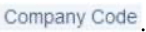 and type DN00 for Company Code and confirm it with enter. In the tab ‘Customer: Account Management’, enter 110000 for Reconciliation acct. and 001 for Sort Key.

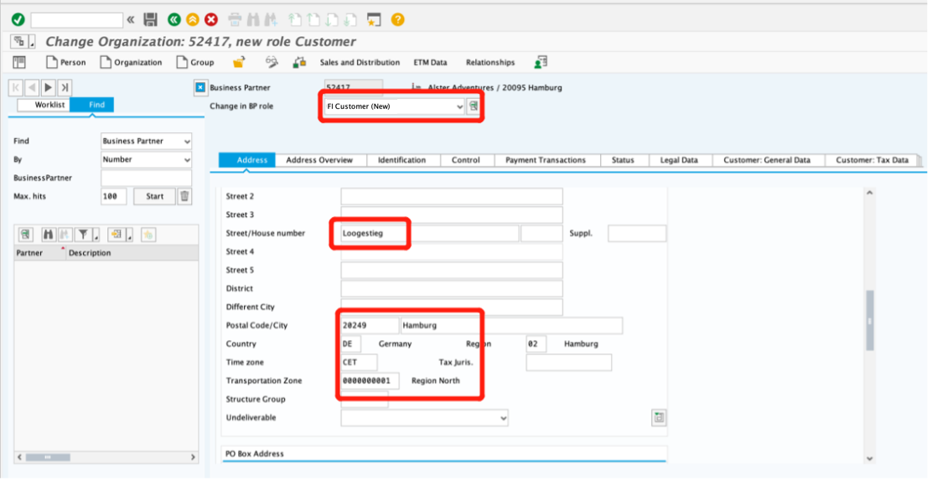

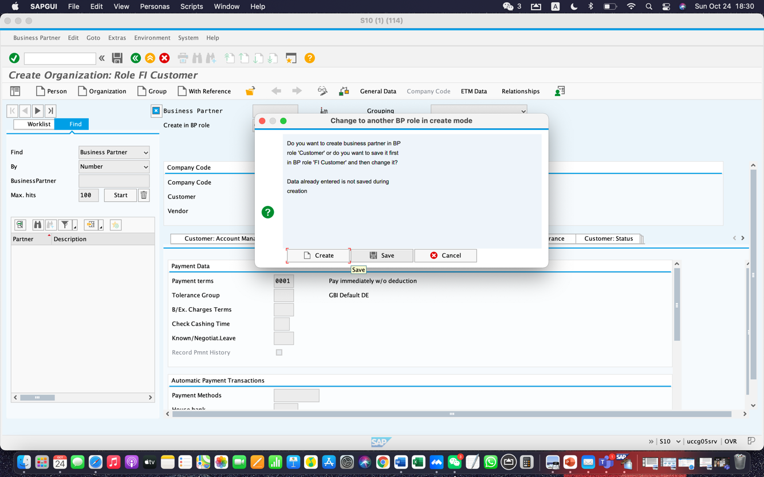

After filling in the information, change ‘Create in BP Role’ into **Customer** and click save. Next, go to Sales and Distribution to establish 3 divisions-– **AS, 00, and BI.**

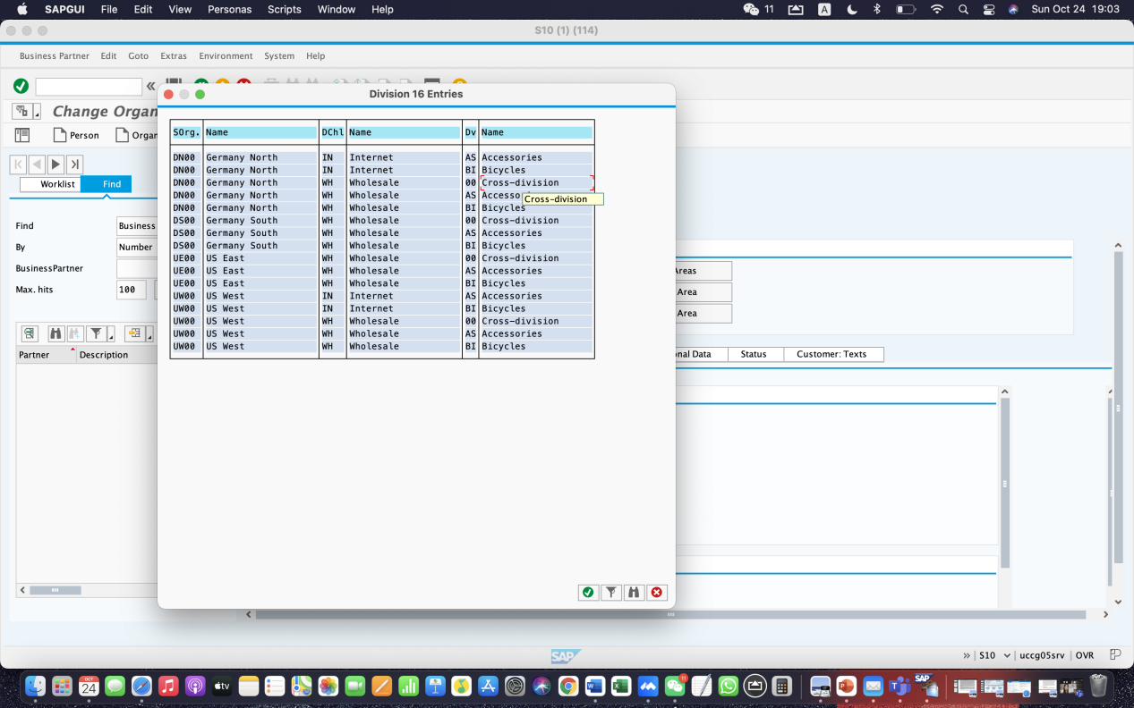

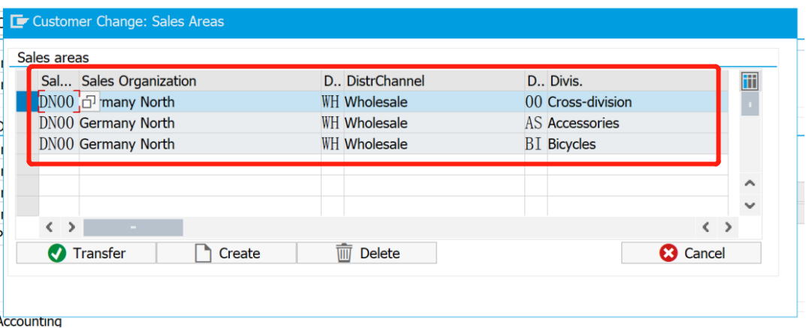

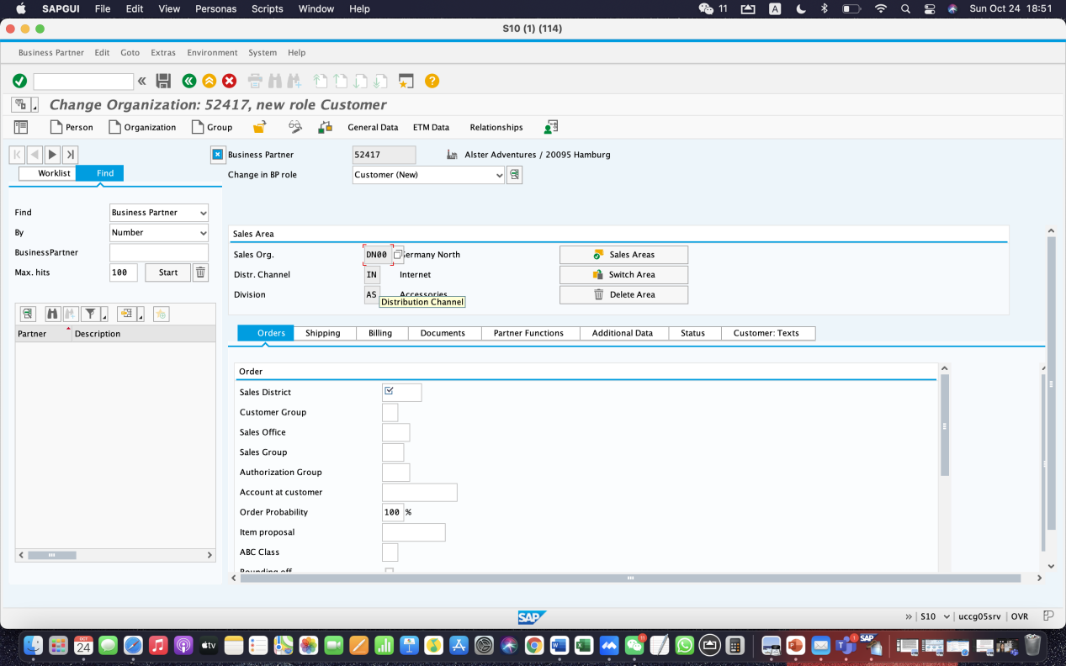

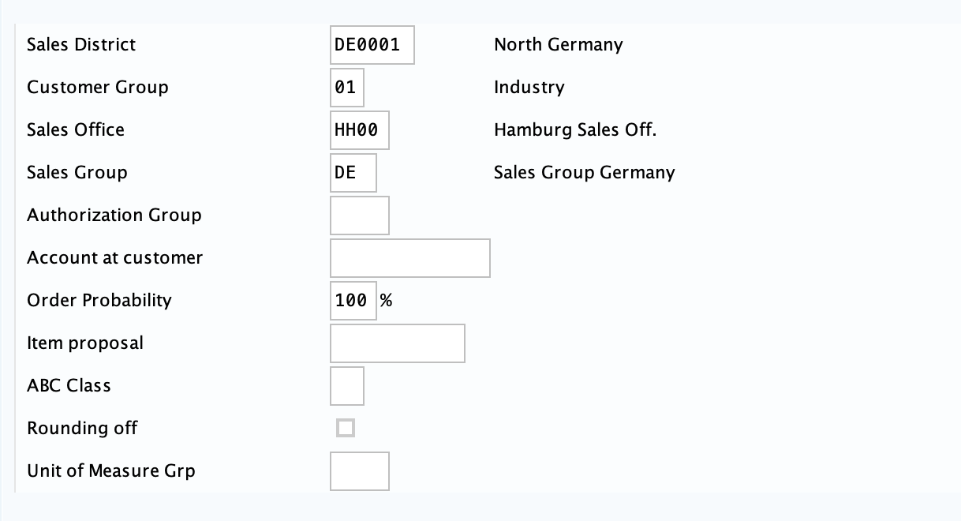

**Step 2: Create Contact Person for Customer**

The aim is to create the contact of *Alster Adventures*. Our contact person to *Alster Adventures* is **Li Yuncong,** with a BP number of **52430.** Fill in the form according to the picture below.

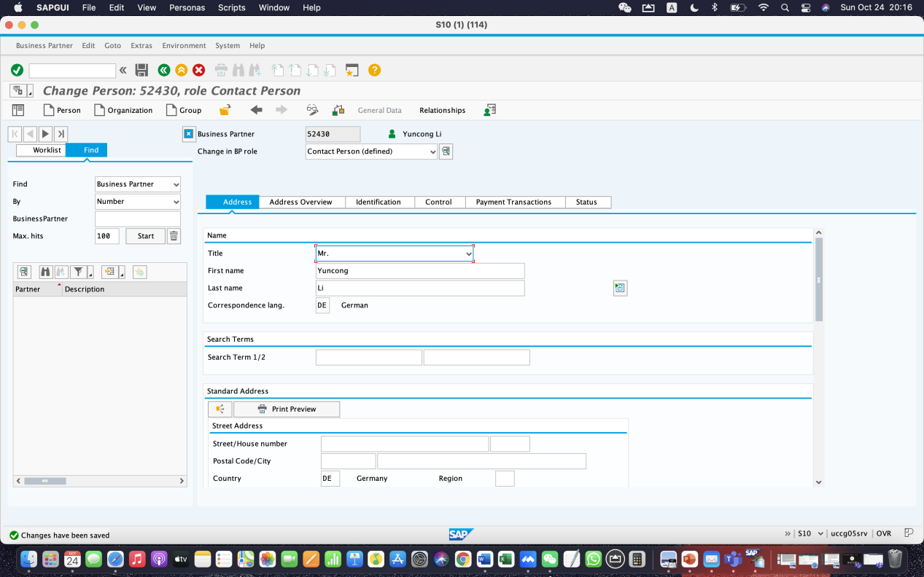

**Step 3: Create BP relationship**

Run transaction **VD02** to create BP relationship. In the field “Relationship to BP” enter the **number of your contact person.** In this case, we sell two products including bicycles and helmets to *Alster Adventures*, so entering **00** for cross-division. The sales division to **BI** (bicycle division) and **AS** (accessories division) also need to be set. After creating 3 divisions, check Sales Area.

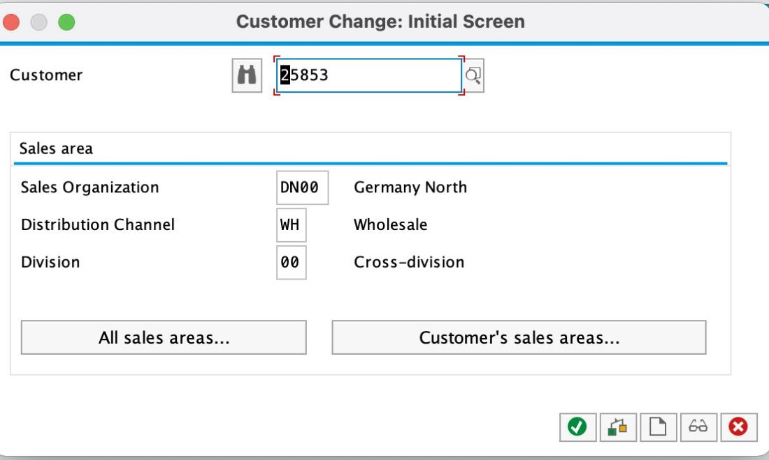

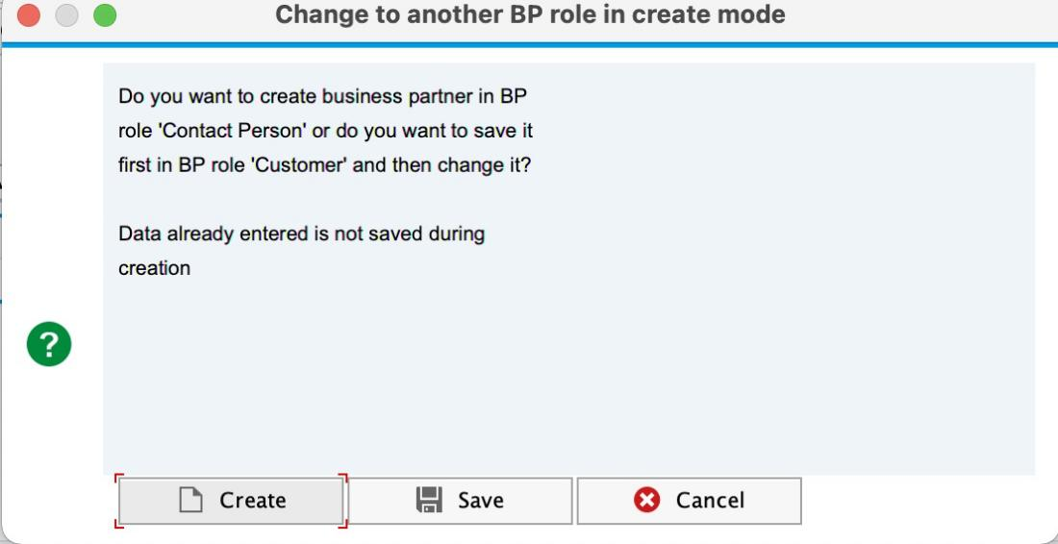

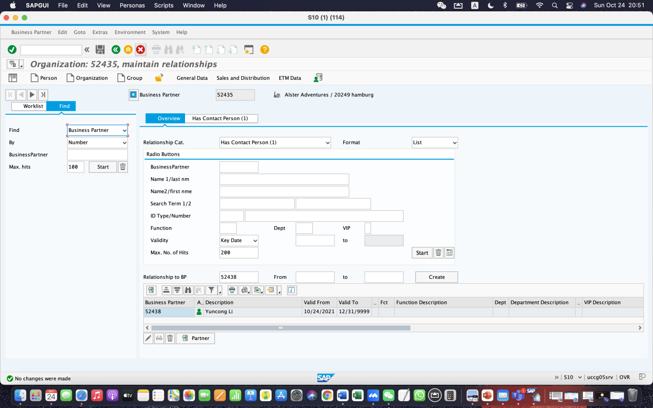

**Step 5: Create Customer Quotation-Response to Alster Adventures’ s inquiry**

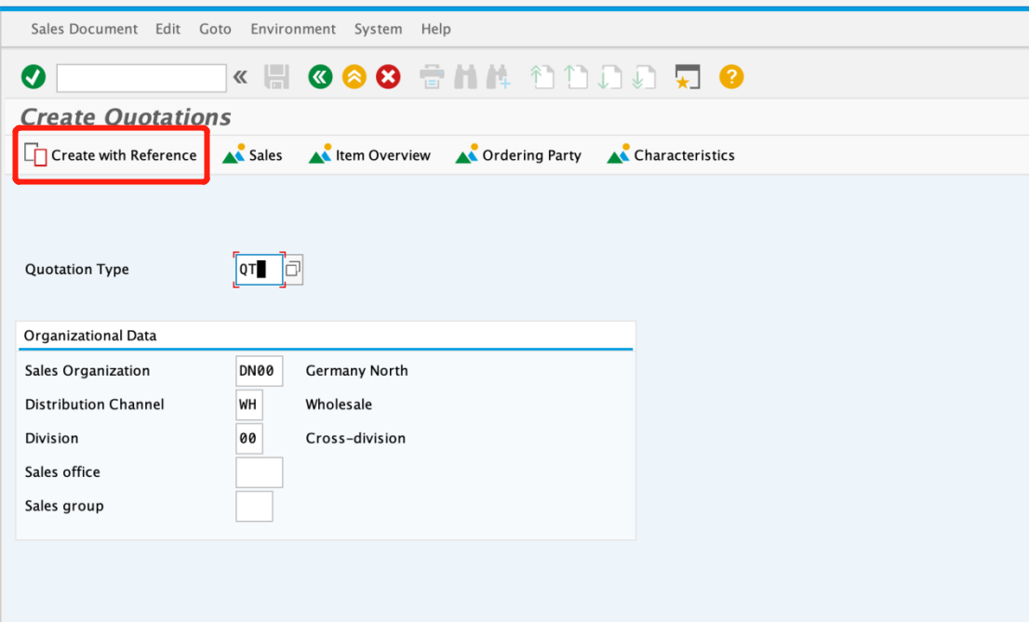

Enter **QT** for Quotation Type, then click on **Create with Reference**.

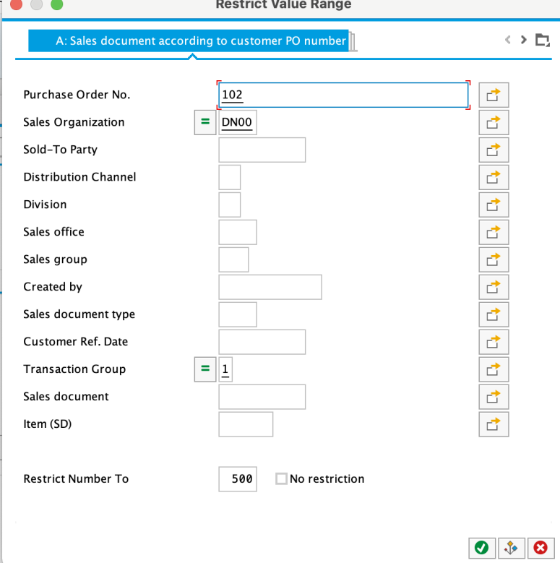

In the Sales document according to customer PO number tab, enter Purchase order no. **102**, then click on. This will produce a list with inquiry **10000578**.

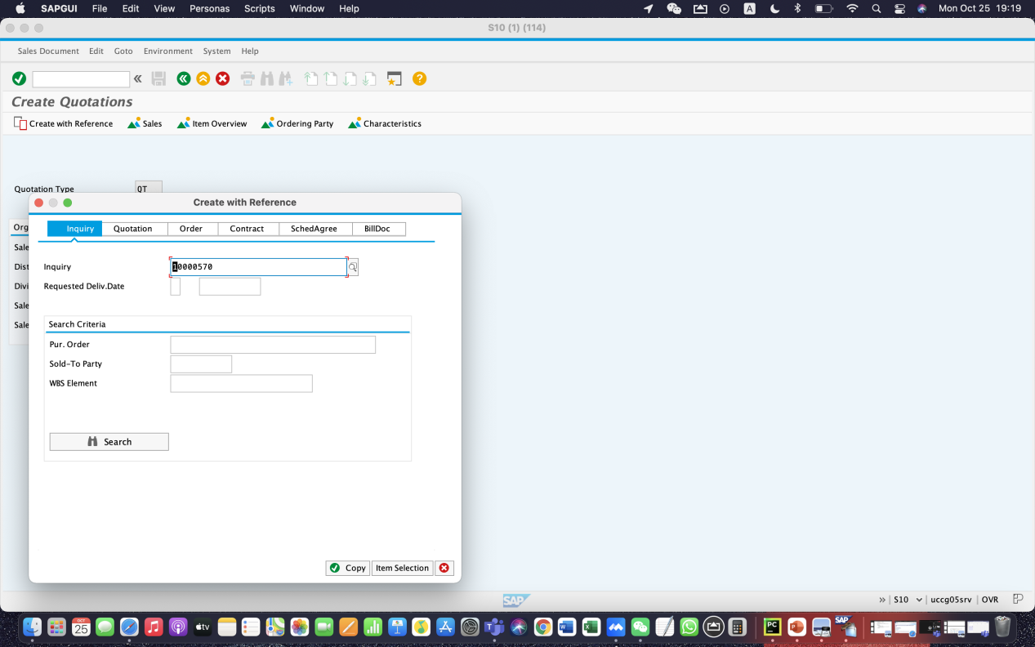

Click on the button 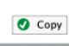to copy information from the inquiry into the quotation screen.

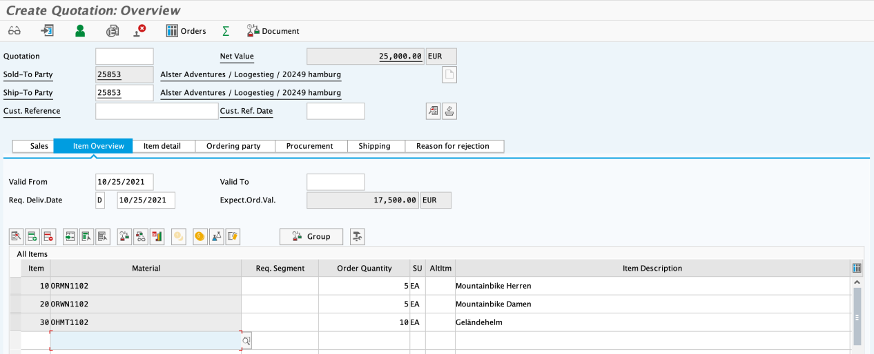

Enter **102** as Cust. Reference again, today’s date for the Cust. Ref. Date, a date one month from today for the Valid to date, and a date one month from today for the Req. Deliv.Date. Then click Enter, which will produce the following warning.

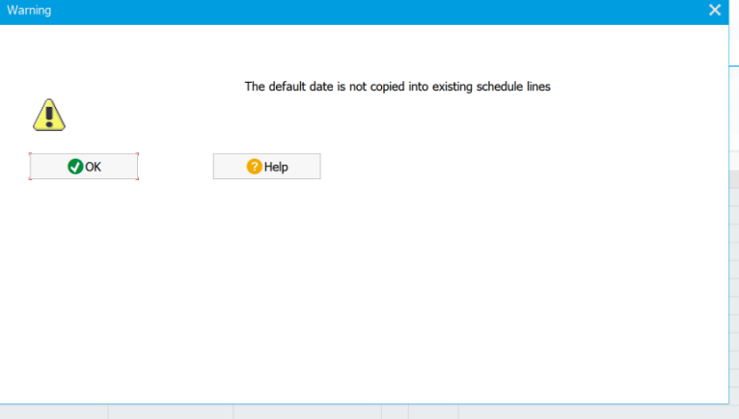

Press enter to confirm.

**To add discount to items:**

Add discount **K004** (material discount) for each Men bike and Woman bike respectively. Their amounts are both **50**.

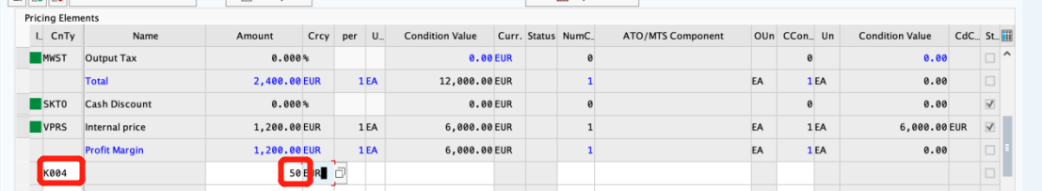

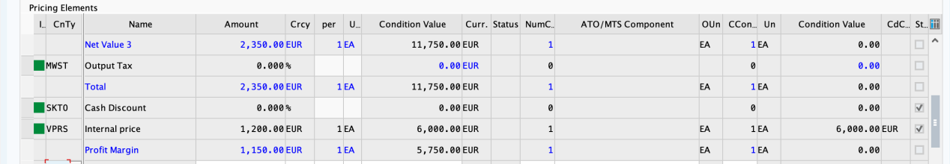

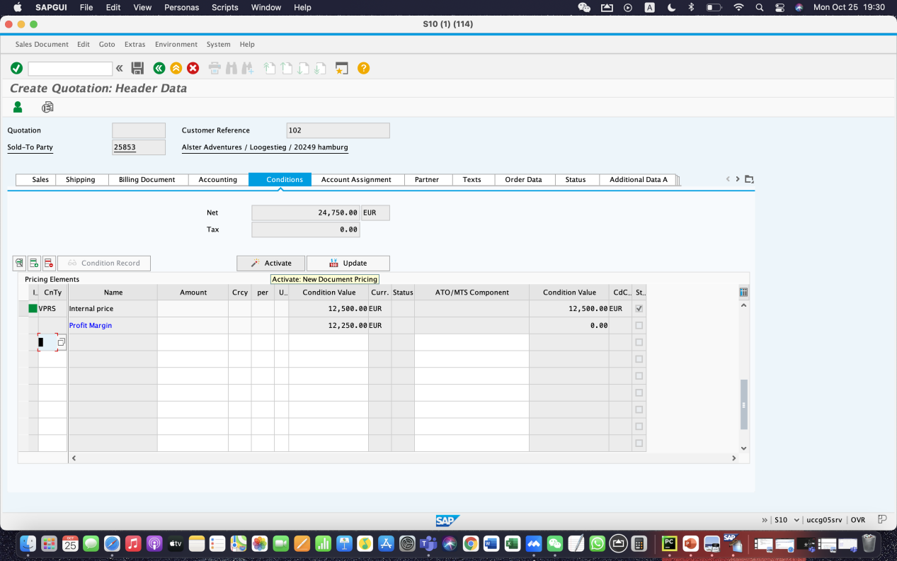

For off-road helmets, press Sales A, in the Order Quantity field, fill **10**. Change the Order Probability to **100**.

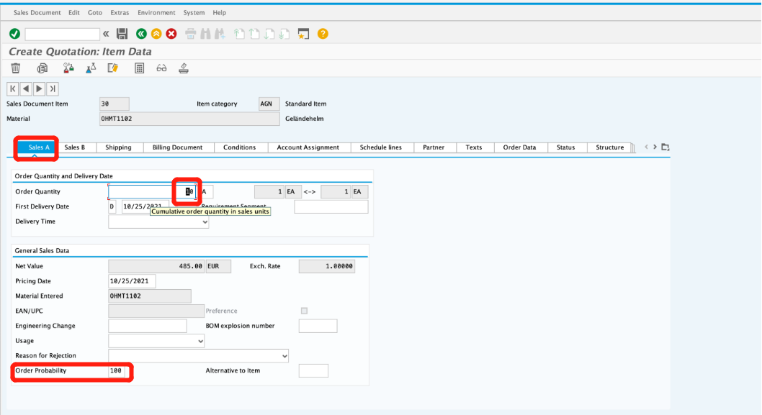

To apply a 3% discount to the entire order, follow the pull-down menu path:

**More ► Goto ► Header ► Conditions**

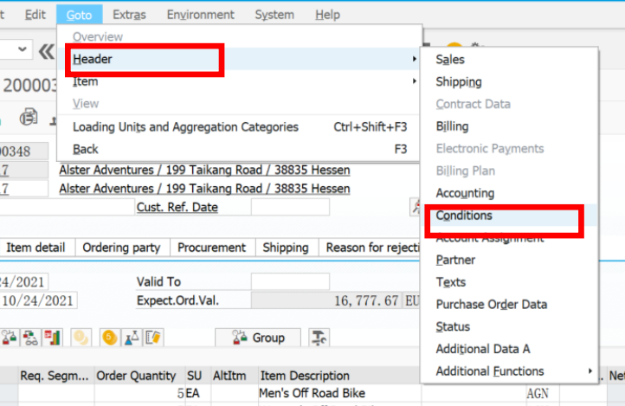

Enter CnTy (condition type) **RA00** (Net Discount) with an amount of **3**, then click Enter. Note that the price does not yet include the 3% discount.

To include the 3% discount, click on the **activate icon**.

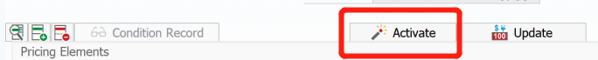

Now The 3% discount is applied.

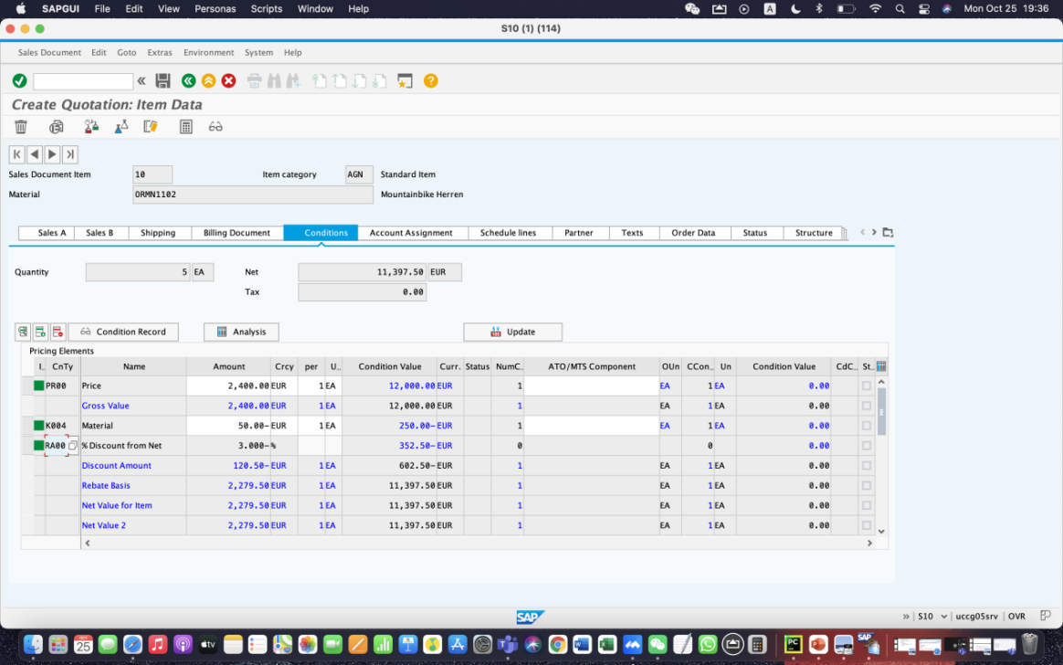

Therefore, for RA00 line, the amount is **3** and CnTy is **%.**

Press save.

Press edit.

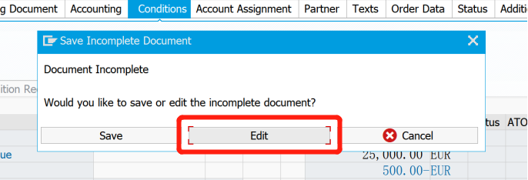

Use VA22 to change quotation change Item Category to **AGNN** (free of charge).

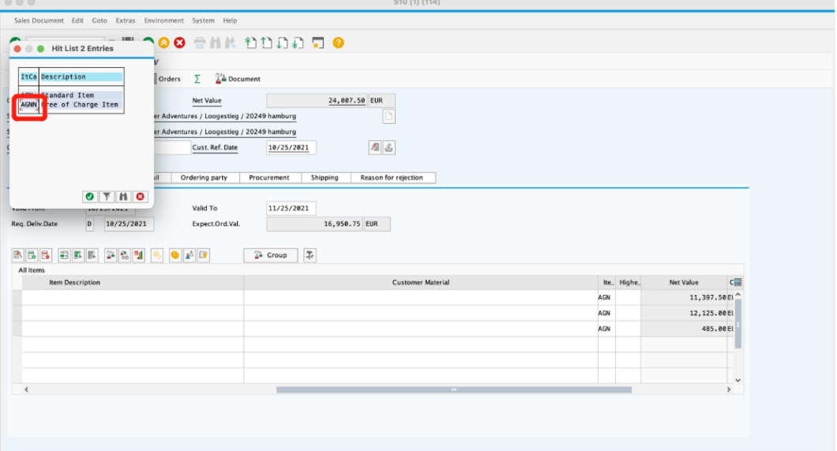

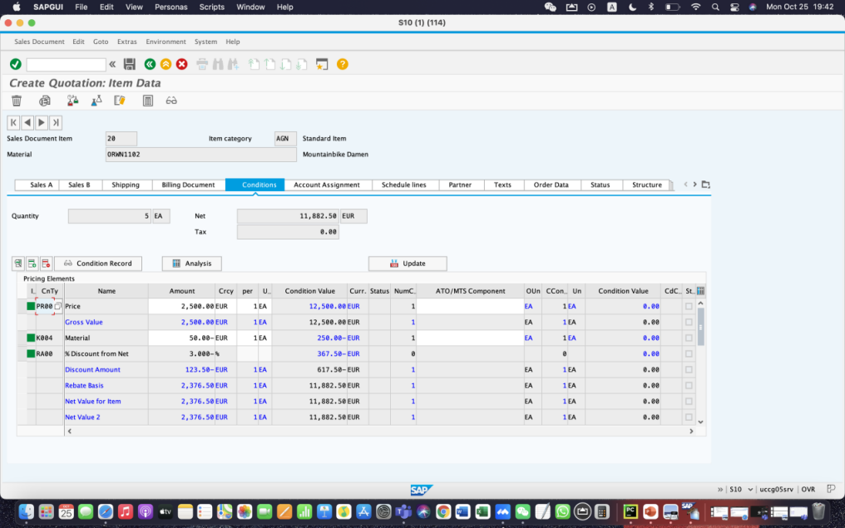

Find ‘Billing Document’ to fill **FOB** in Incoterms and **Hamburg** in Inco. Location

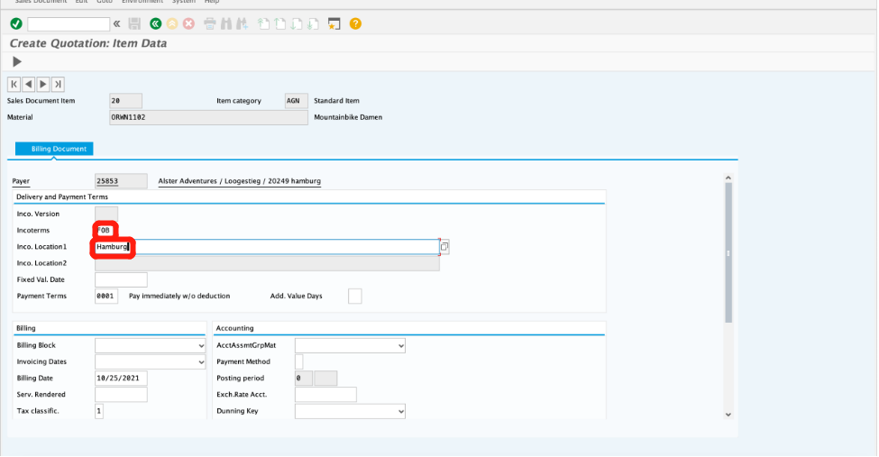

Press save, then exit.

**Step 6: Create Sales Order Referencing a Quotation**

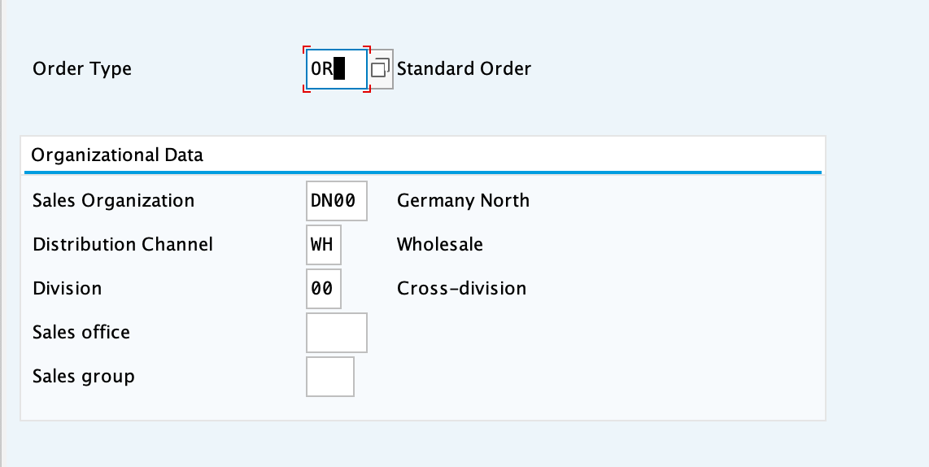

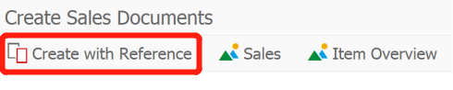Enter Order Type **OR**. The other ­­­­­fields do not necessarily need to be filled. Then, click on the Create with Reference icon.

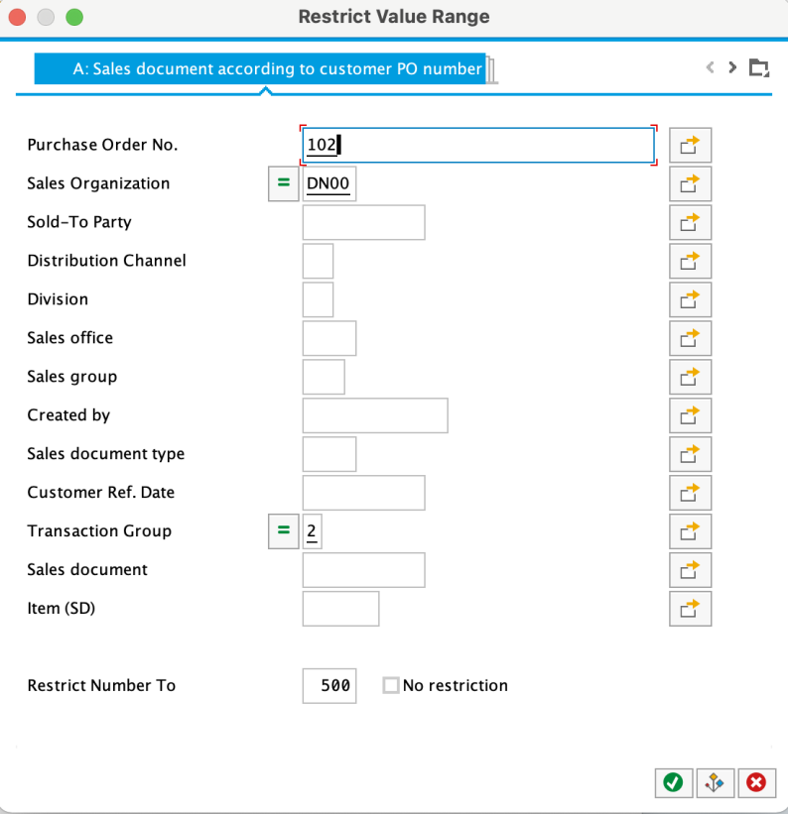

Select the Sales document according to customer PO number tab, enter **102** for PO number, then click on the enter icon

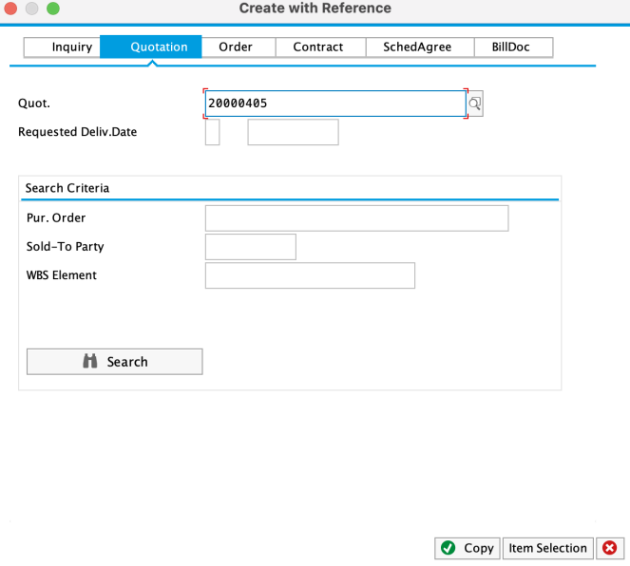

With the Quotation number **20000405** entered, click on Copy to copy the information from the quotation into the sales order screen.

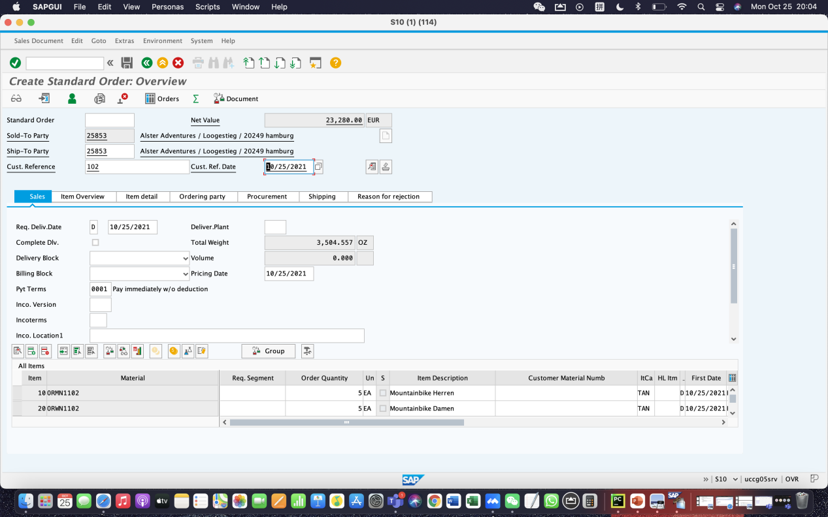

Enter **102** for Cust. Reference and today’s date for the Cust.Ref. Date. Note that the Req.deliv.date is copied from the quotation. Click on save to save the sales order. The SAP system will assign a sales order number.

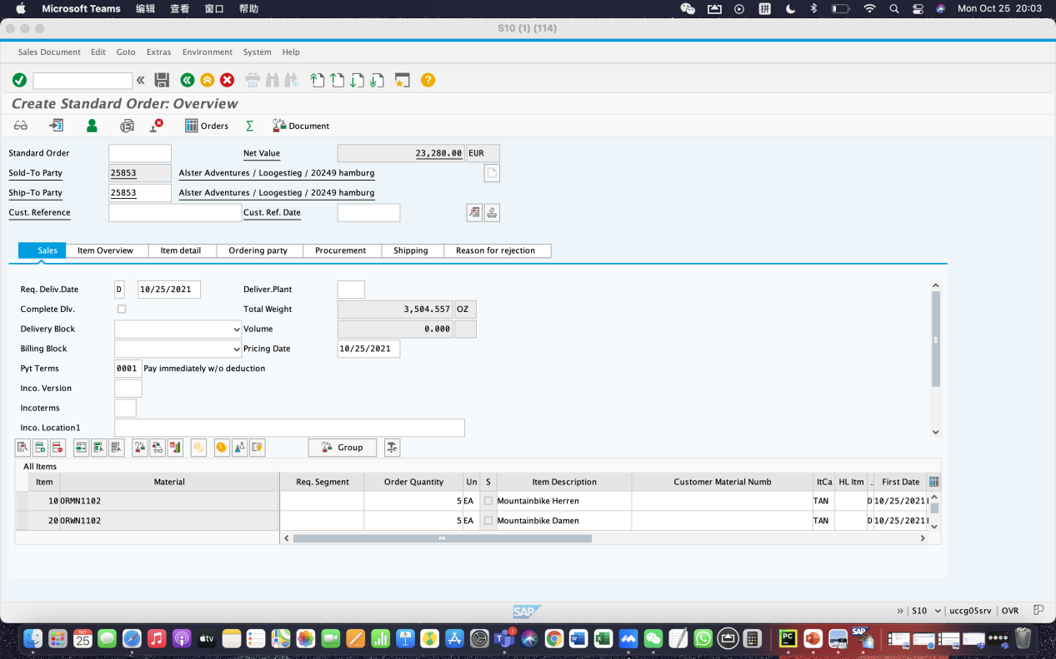

Click save, then exit.

**Step 7: Check Stock Status**

Use the far-right icon to select the tab Sales Material by Description. 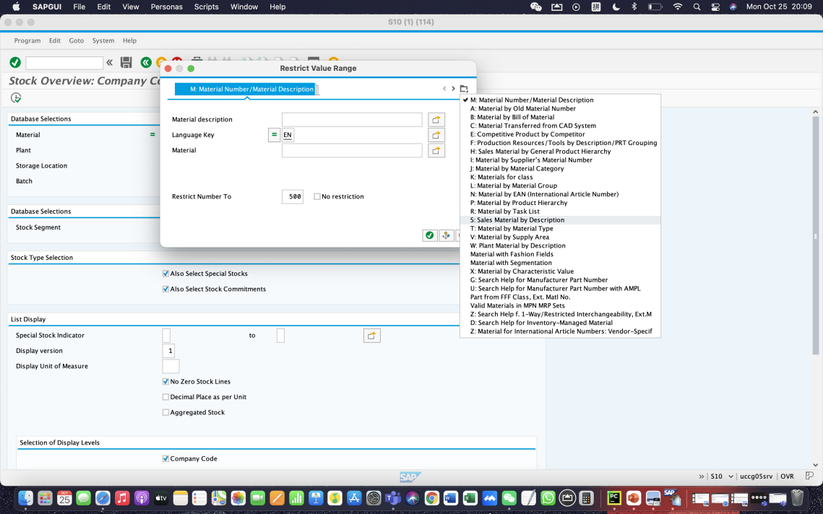

Enter **DN00** for Sales Organization, **WH** for Distribution Channel and Material **\*102** .

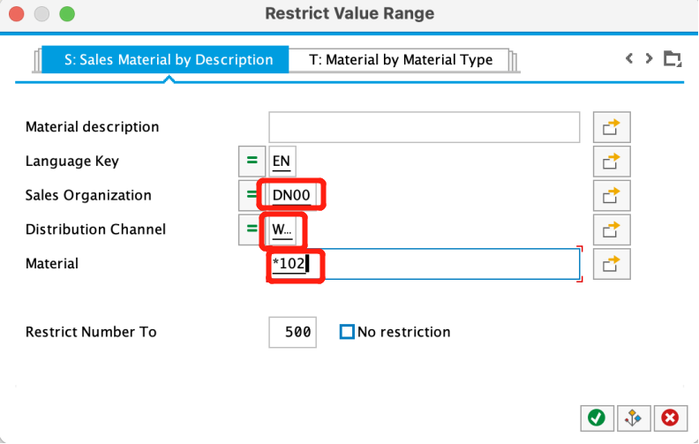

Then click the enter icon to find the list of materials.

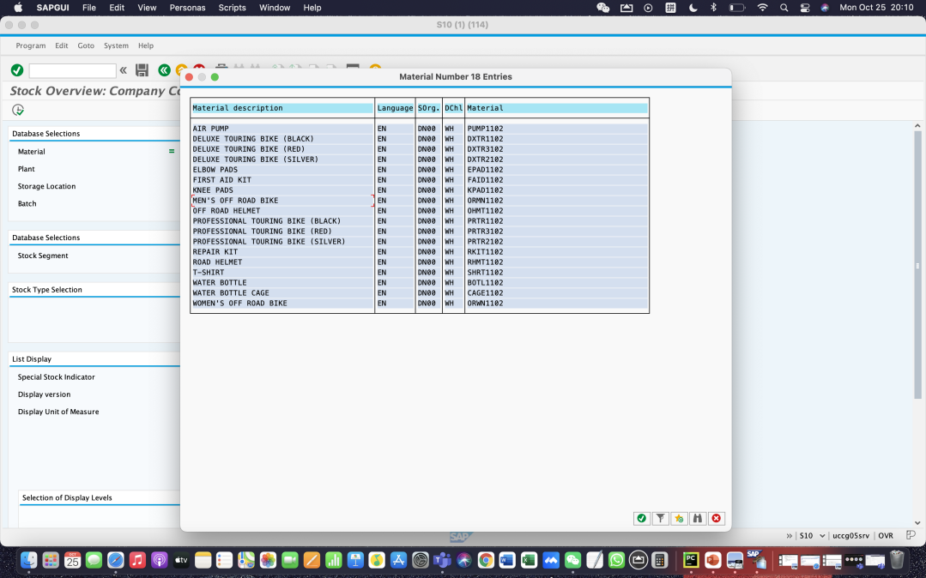

Double-click on the MEN’S OFF ROAD Bike to select it.

With the material number entered from the search list, enter **HH00** for Plant. Then click on 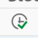(Execute) to look at the stock level.

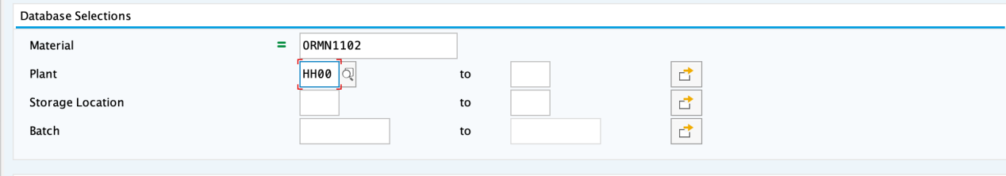

Specific information about the inventory of MEN’S OFF ROAD Bike.

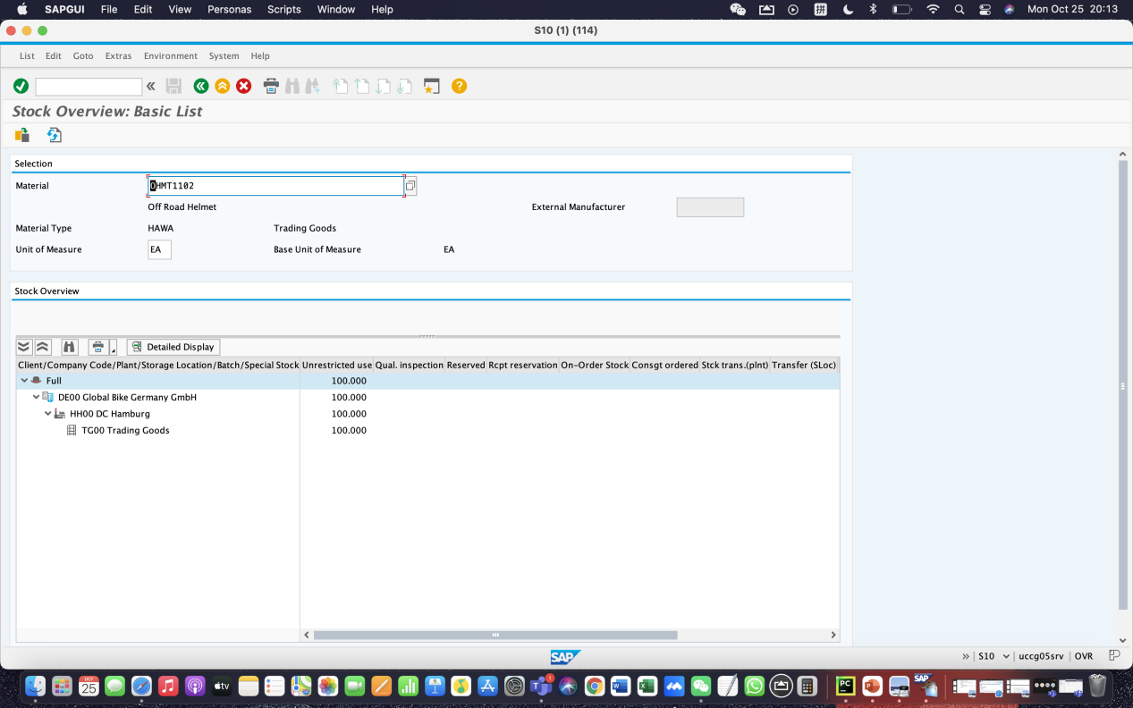

The number of stock is **100**.

**Step 8: Display Sales Order**

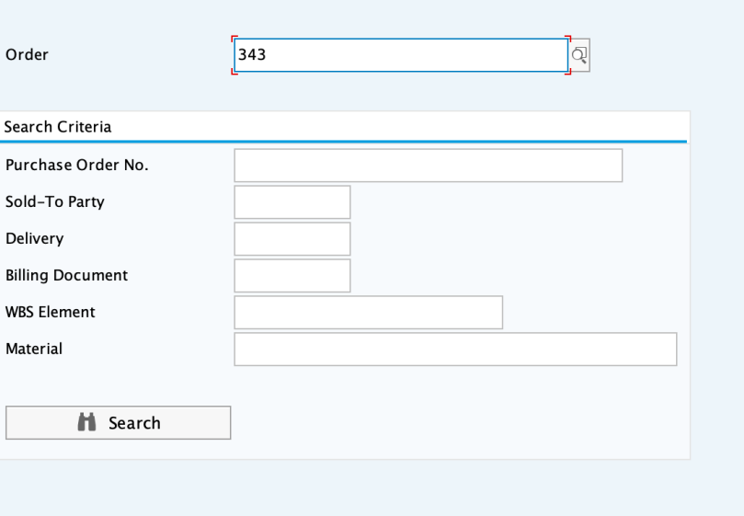

To make sure the sales order number is correct, click on the order field, then click on the search icon. Enter PO number **102.**

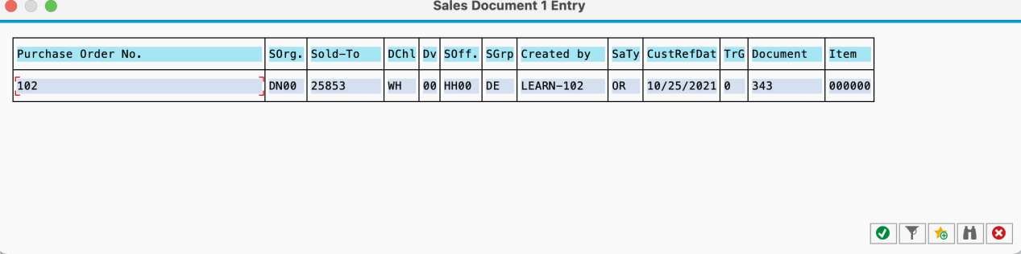

Double-clicking on sales order number, which will produce the following sales order items.

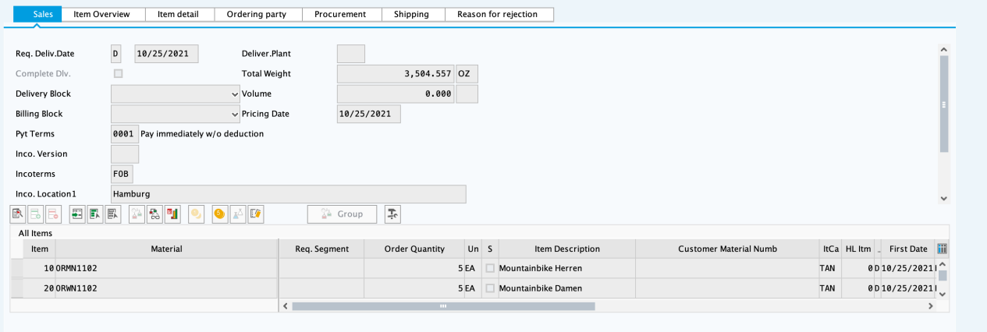

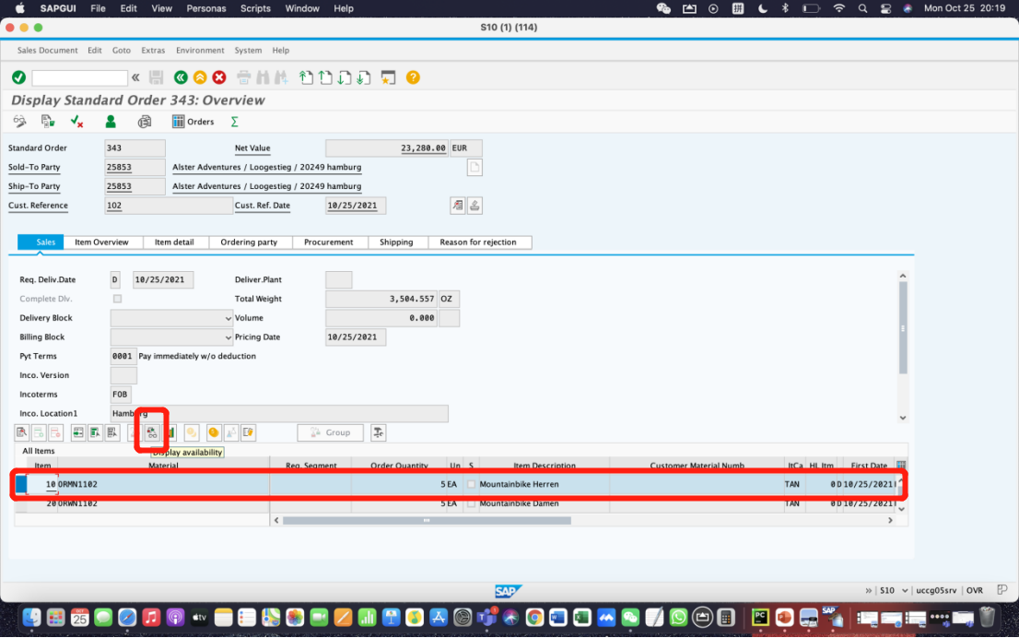

Select the ORMN1102 item, then click on the display availability icon to explore the stock for this item in detail.

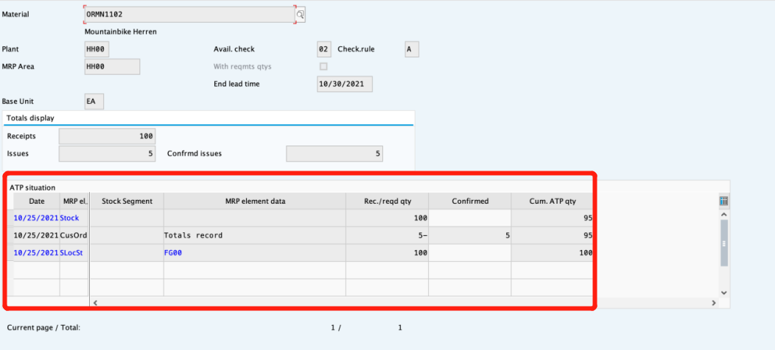

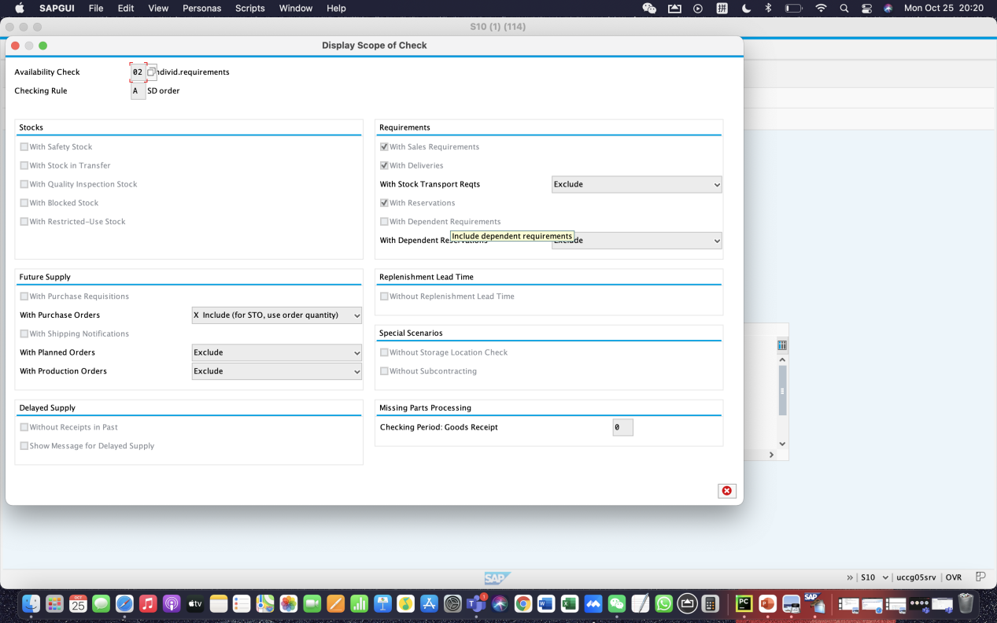

This screen displays the elements considered when performing the availability check.

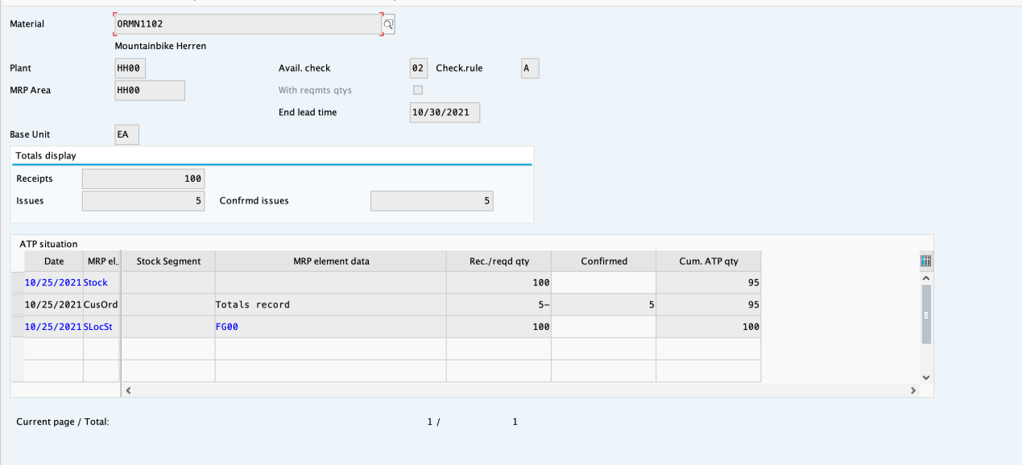

Clicking on the Scope of check icon will produce the following pop-up window, which is Display Scope of Check.

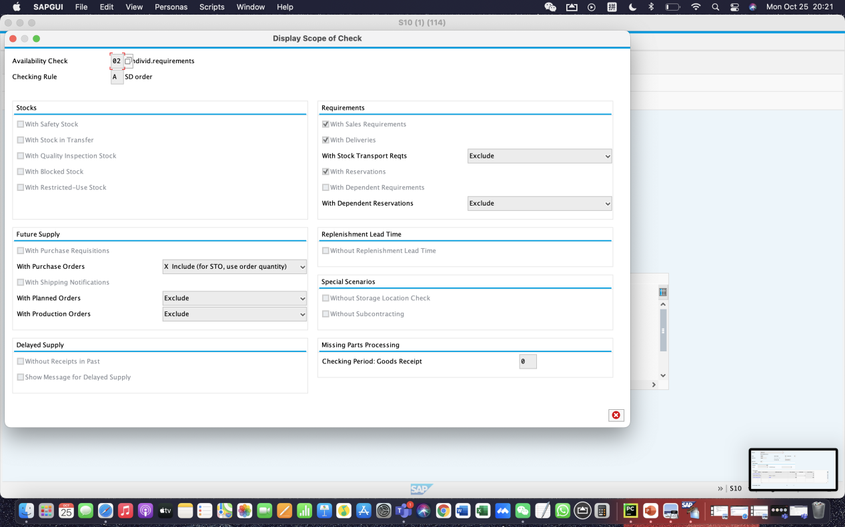

This screen displays the elements considered when performing the availability check.

Click back icon. Do the same above steps to check other items.

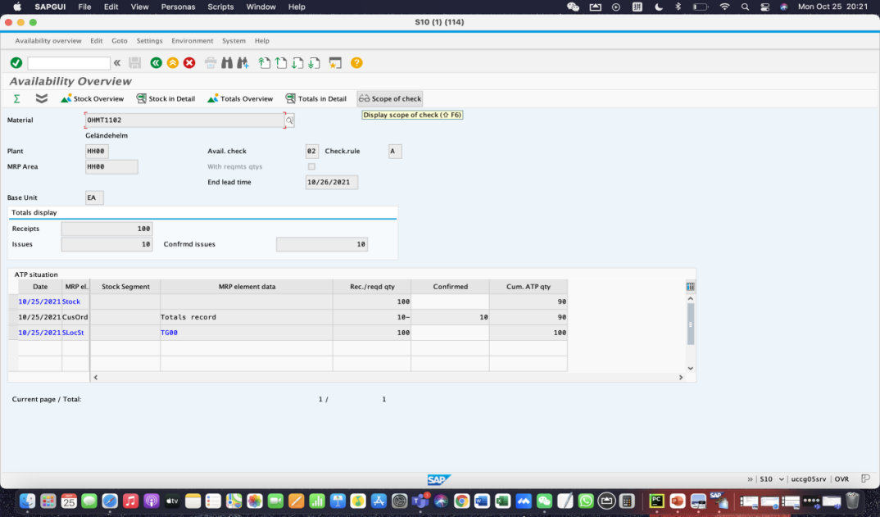

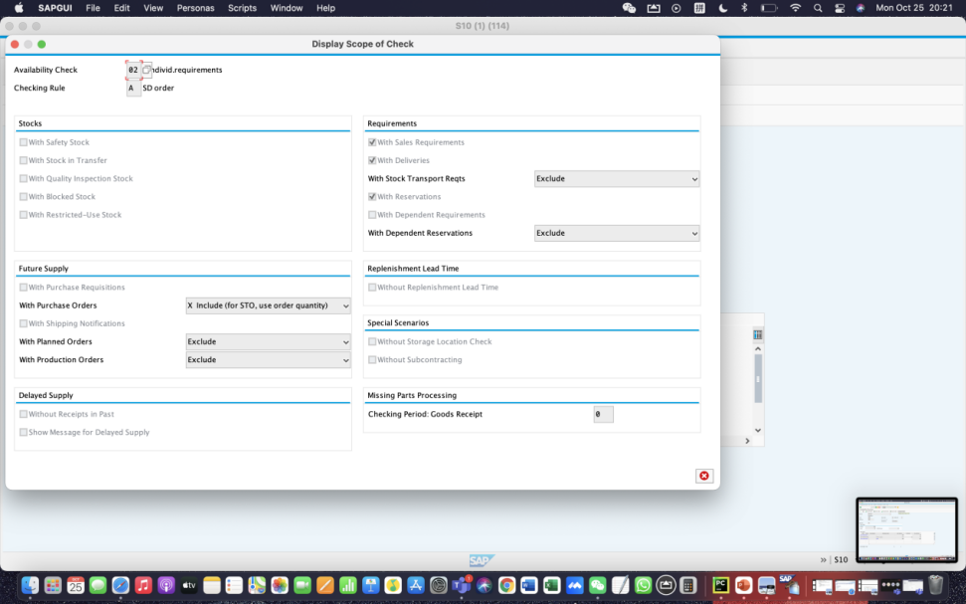

Click back icon, then exit.

Step 9: Start Delivery Process

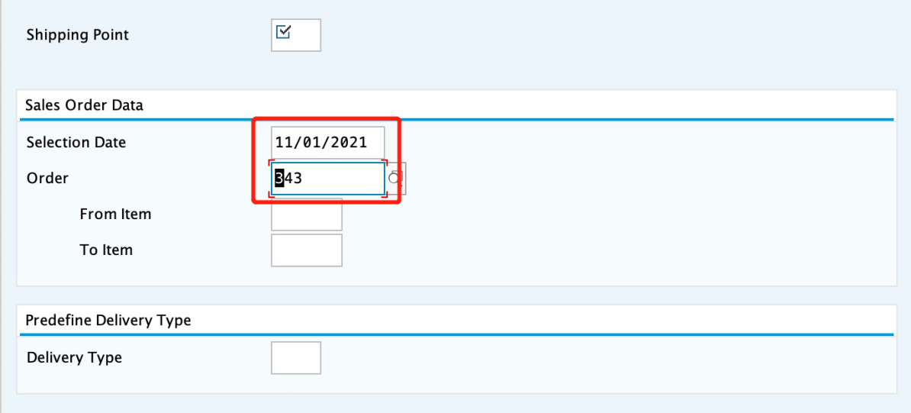

Enter **HH00** for Shipping Point. Enter a selection date one week from today.

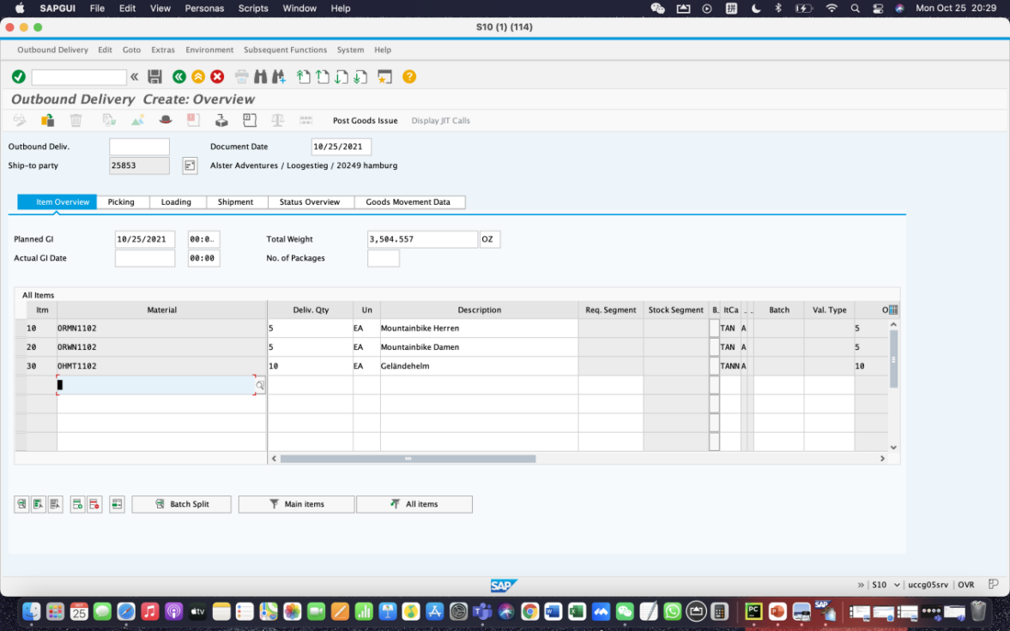

Select the ORMN1102 line, then click on the details icon and choose the Picking tab, which will produce the following screen.

Pick **5** for man’s bike.

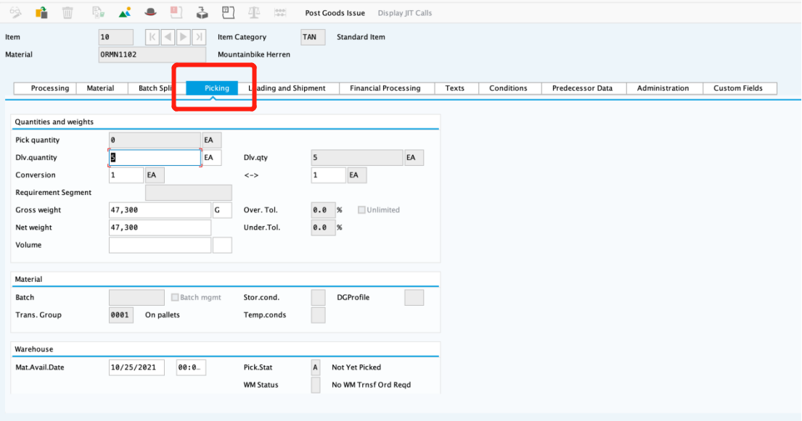

Similarly, pick **5** for woman’s bike.

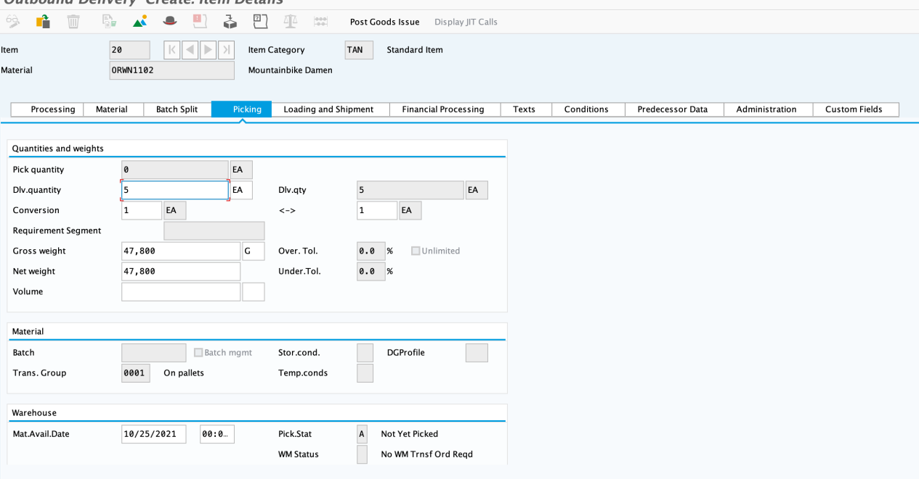

Pick **10** for helmet ’s bike.

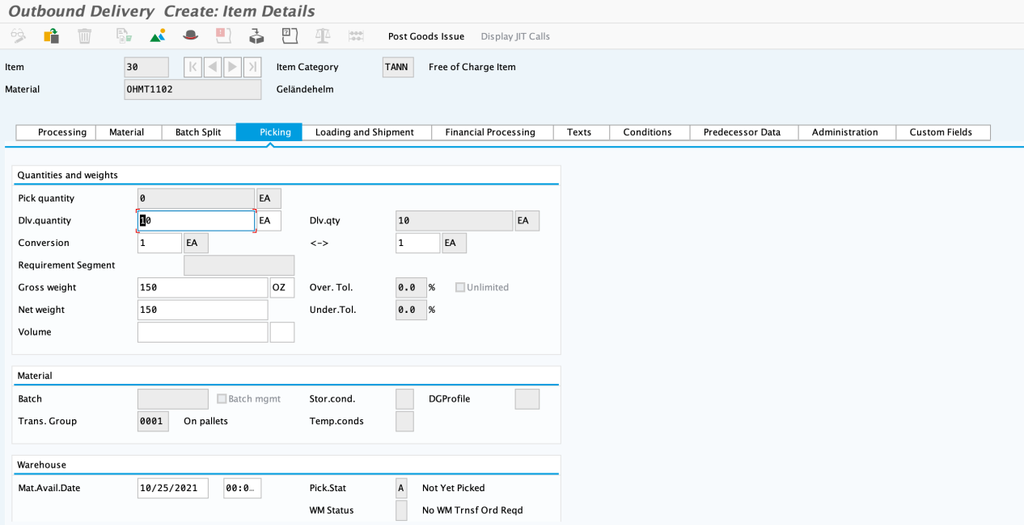

Click back. It will show the following information.

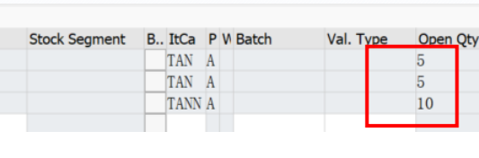

Click Save, then click Exit.

**Step 10: Check Stock Status**

Select the HH00 DC Hamburg, then click Detailed Display icon.

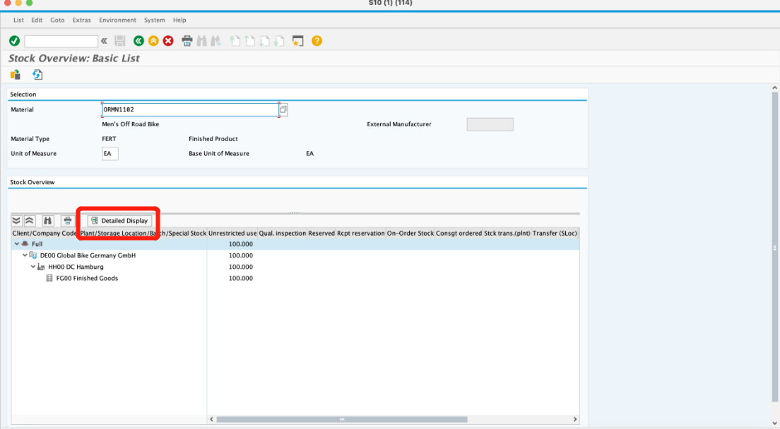

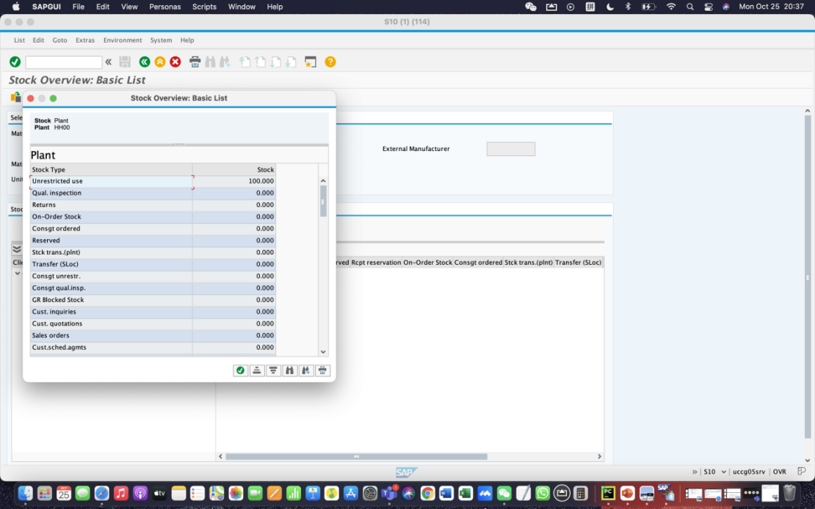

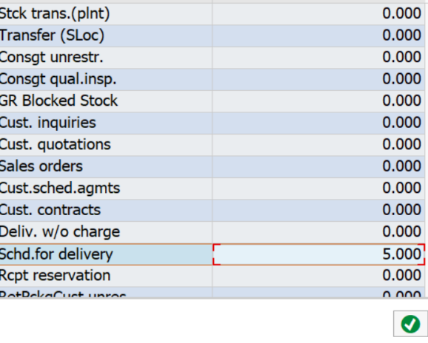

Note that the **5** bikes for Man’s bike are now showed as Schd. For delivery.

The same as Woman’s bike.

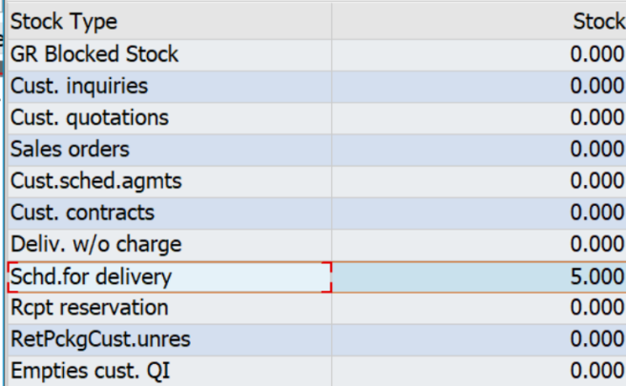

Helmet schd. For delivery **10**

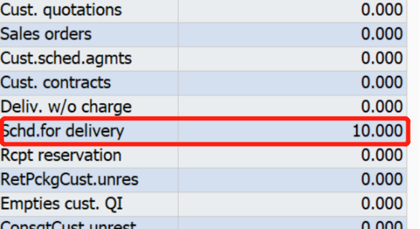

Click on Exit to return to the SAP Easy Access screen.

Step 11: Pick Materials on Delivery Note

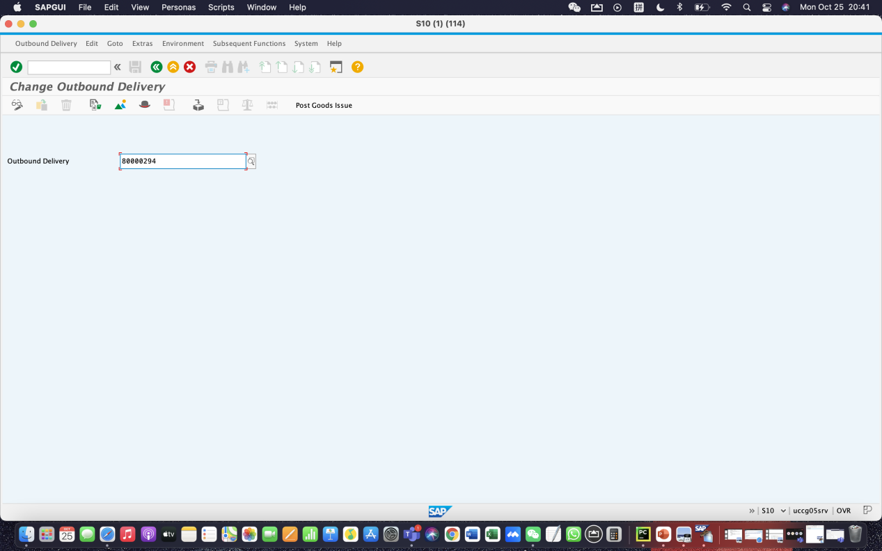

The Outbound Delivery document number. Then click continue.

Click on the picking tab. It will show the following image.

Enter the correct quantity for the picked quantity. **5** for ORMN1102, **5** for ORWN1102, **10** for OHMT1102

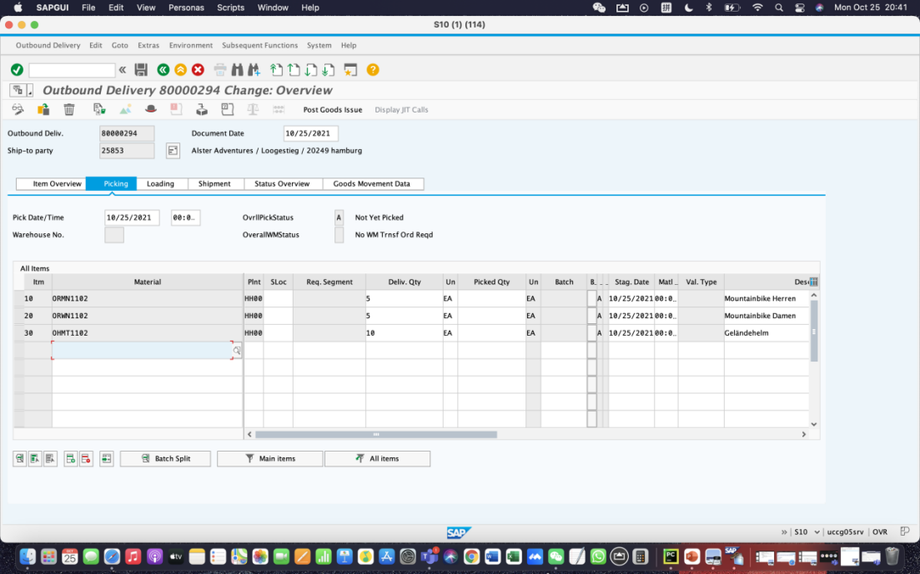

At first, we click save icon without entering **FG00** for SLoc (storage location). It shew the flowing notice.

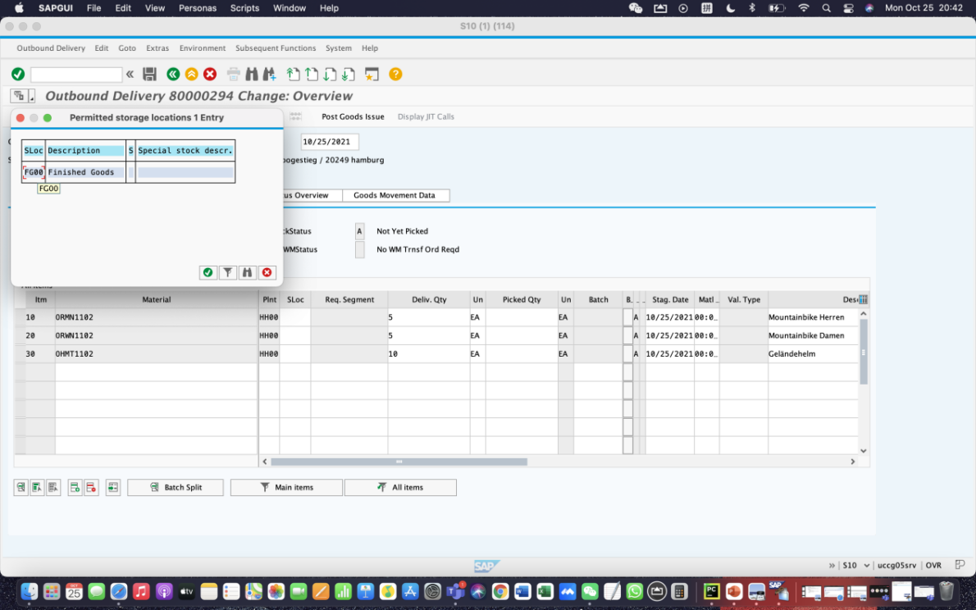

Then we entered it.

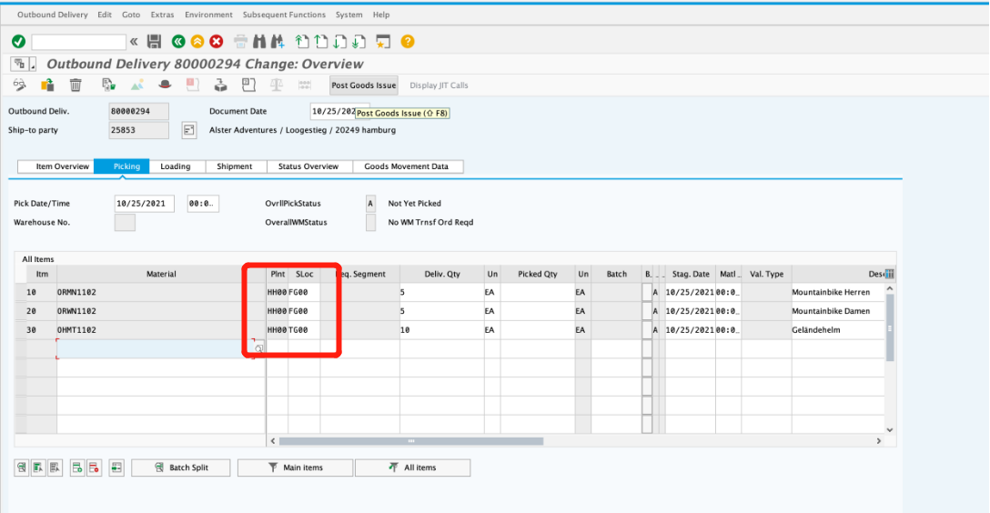

Click save icon, then click exit icon.

**Step 12: Post Goods Issue**

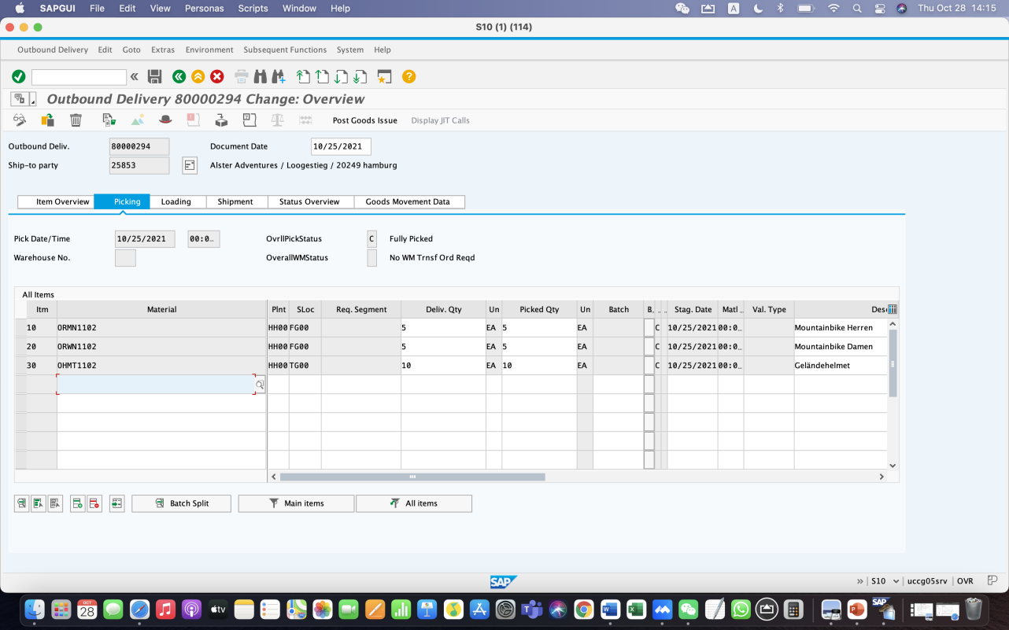

it’s a result of step 12.

**Step 13: Check Stock Status**

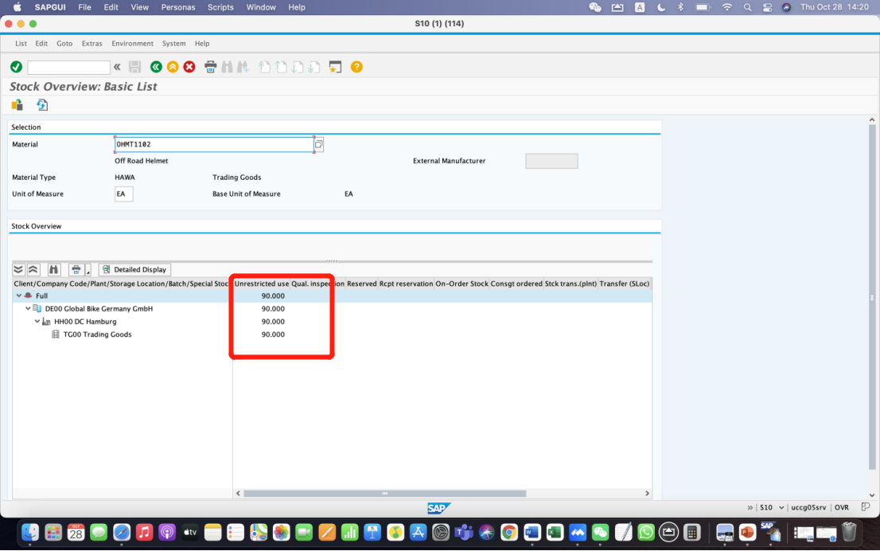

For OHMT1102, select the HH00 DC Hamburg, then click on the Detailed Display icon.

The inventory is reduced from before by the amount that used to appear as Schd. for delivery.

The reduction is 10, so Unrestricted use field is **90**.

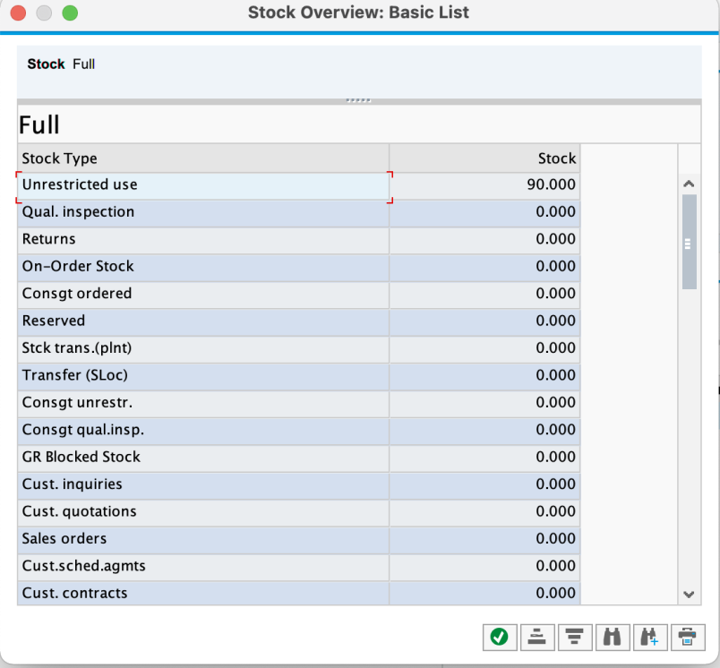

Similarly, for ORWN1102, the reduction is 5, so Unrestricted use field is **95**.

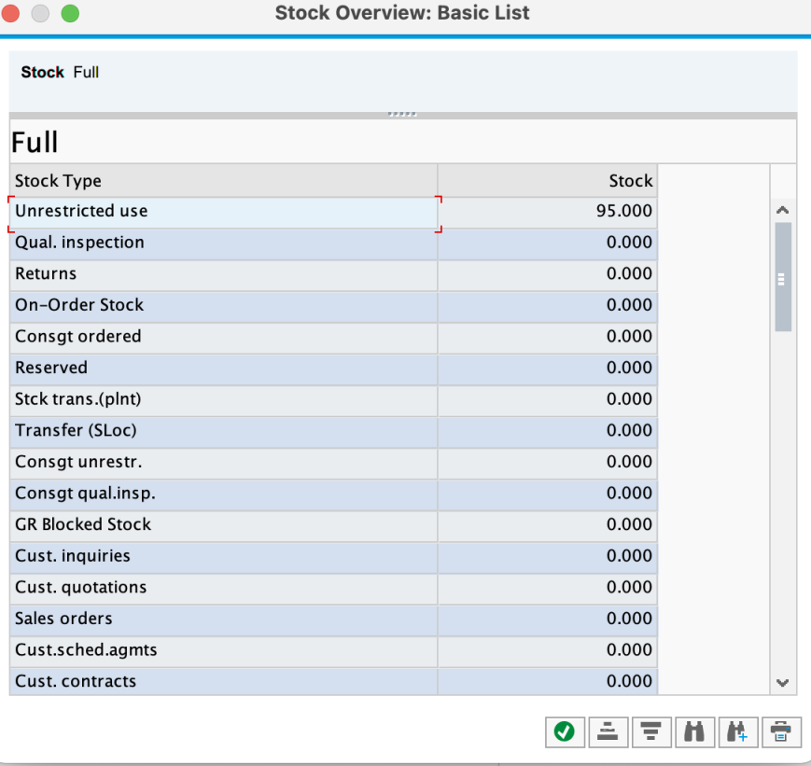

For ORMN1102, the reduction is also 5, so Unrestricted use field is **95**.

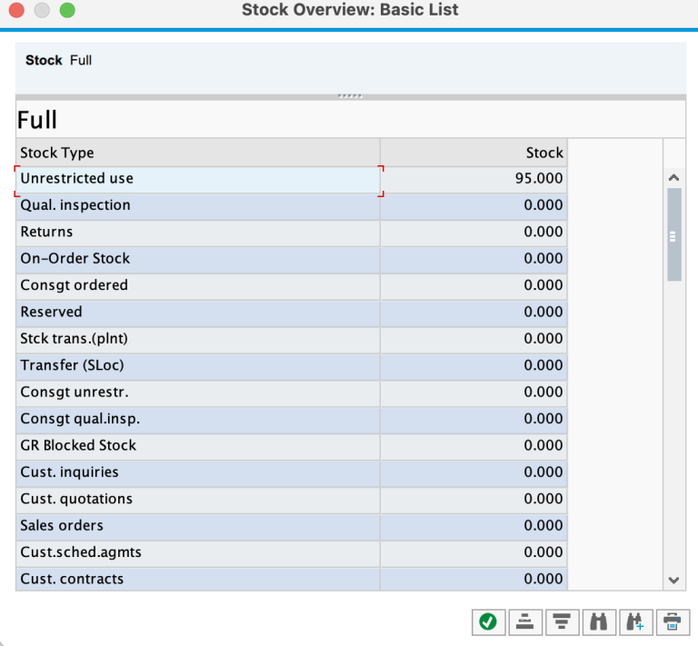

Step 14: Create Invoice for Customer

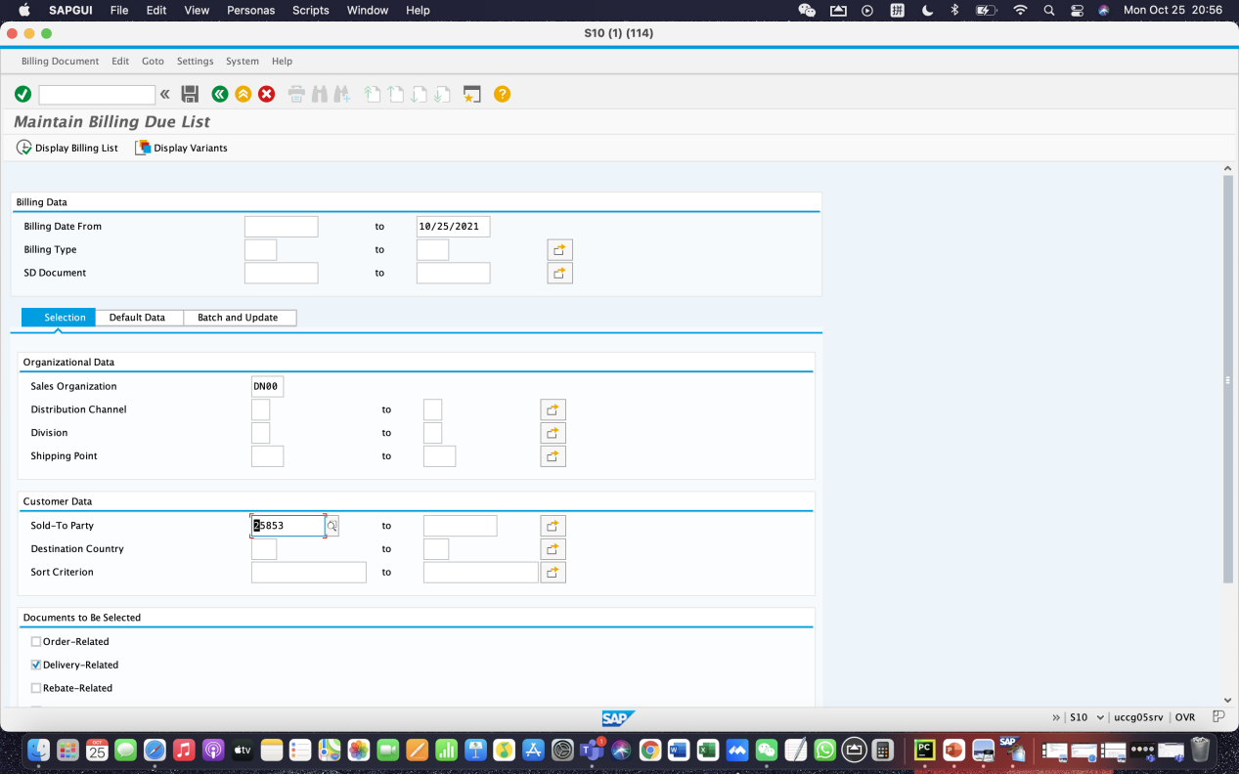

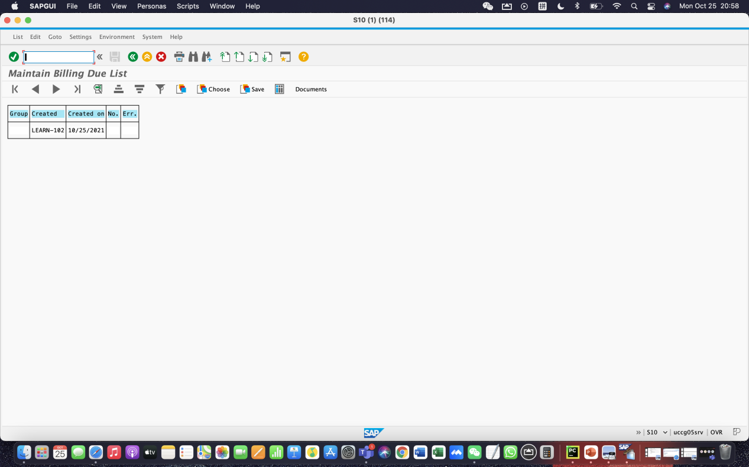

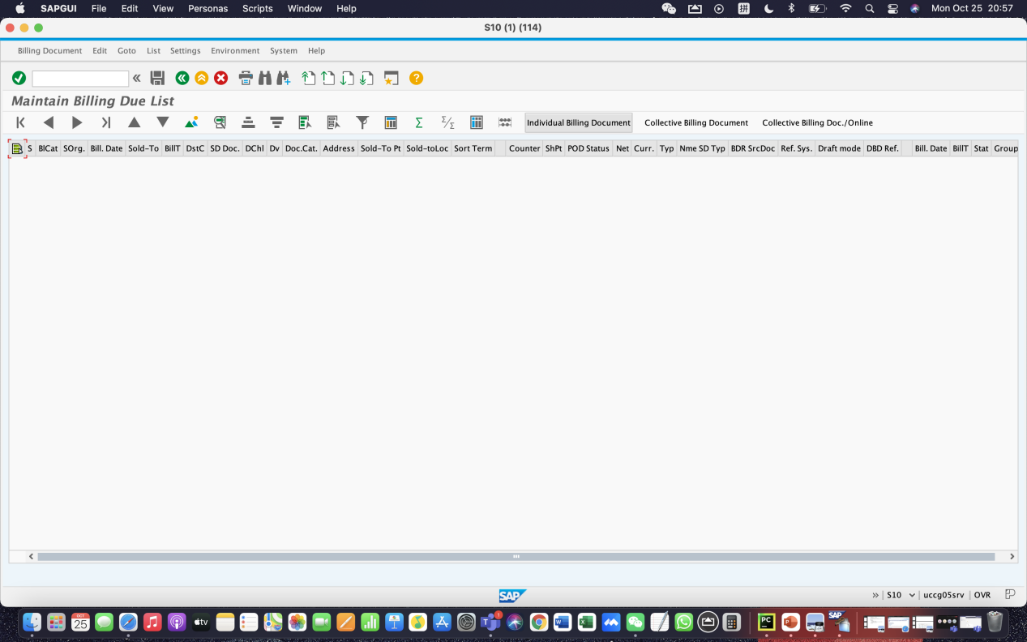

**Step 15: Display Billing Document and Customer Invoice**

Open the application **VF04**, enter **DN00** as sales organisation, **25852** as sold-to party. By clicking the button “display billing list”, the SAP system shows the billing details. Then click on “individual billing document” and save it. The number of our billing document is **90000193.**

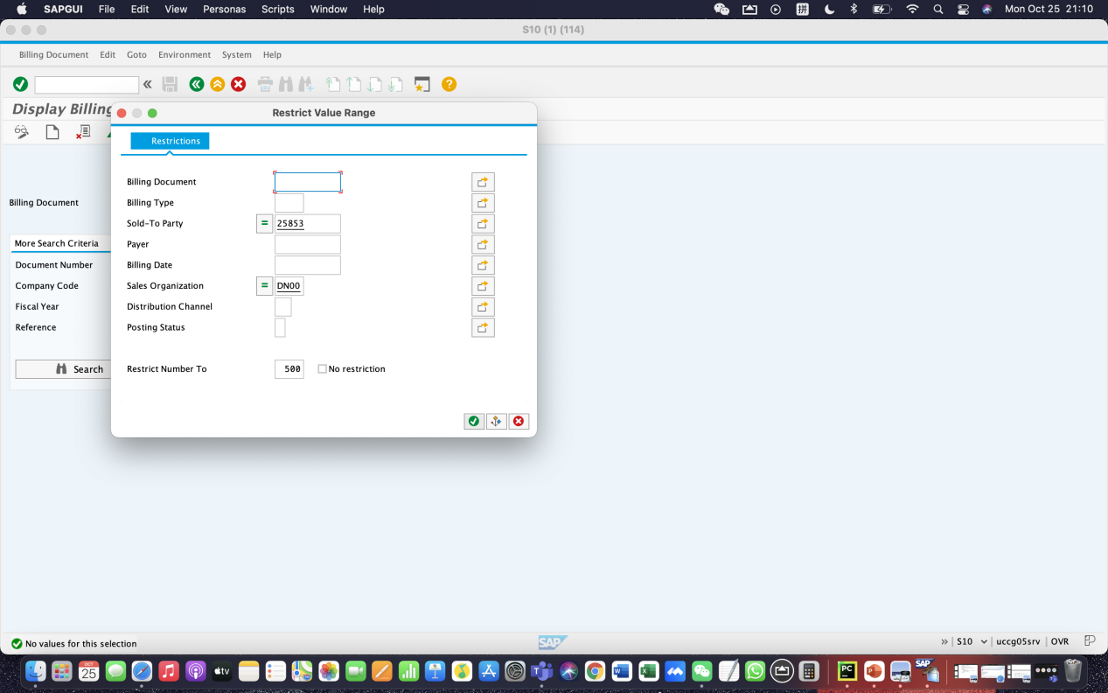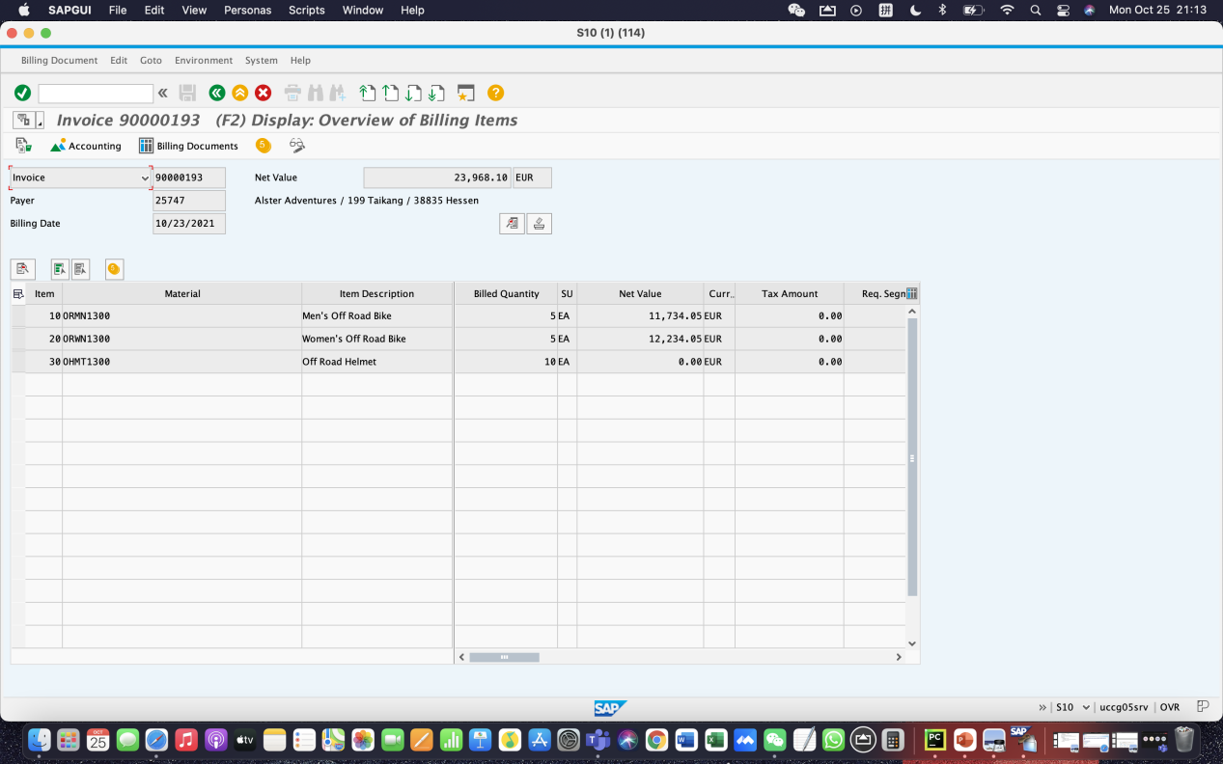

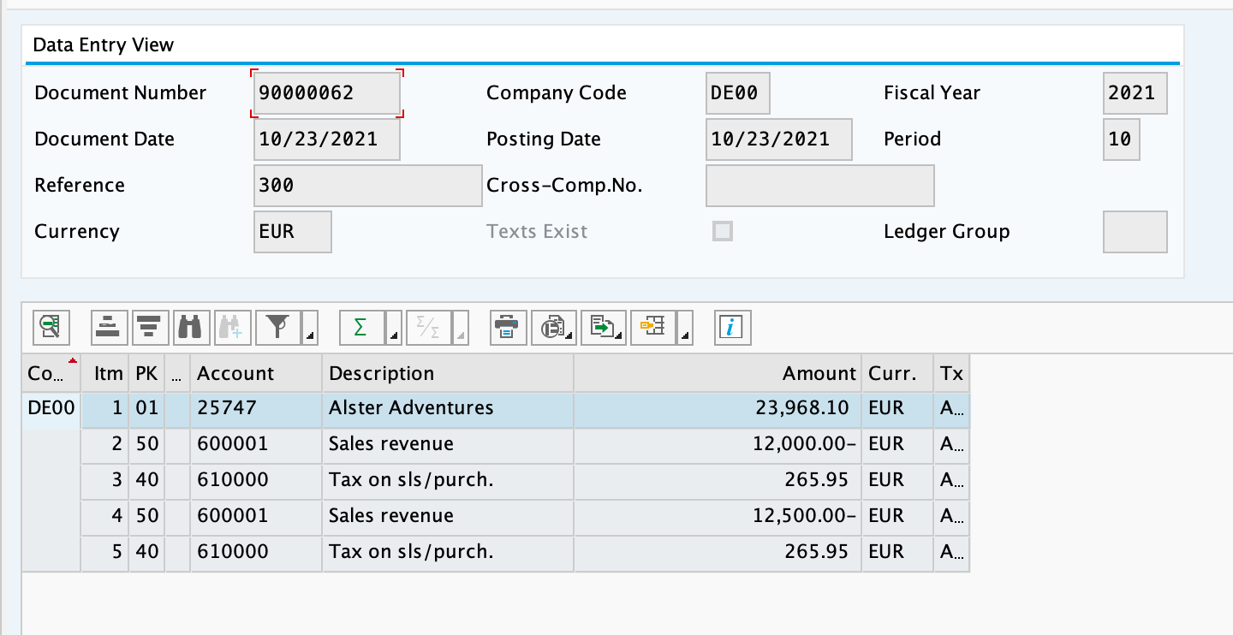

**Step 16: Post Receipt of Customer Payment**

Enter **current date** for document date, **DE00** for company code, **EUR** for currency, **100000** for account and **23,249.06** for amount. Enter our customer code **25853** and start the searching process.

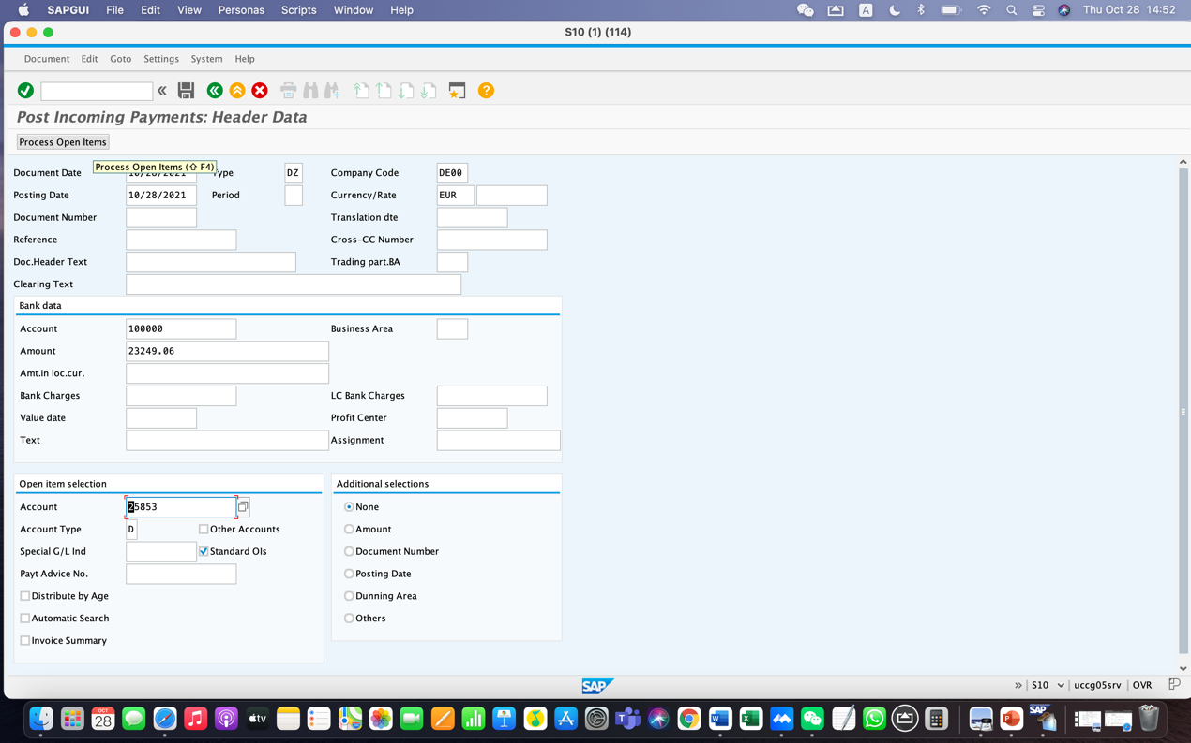

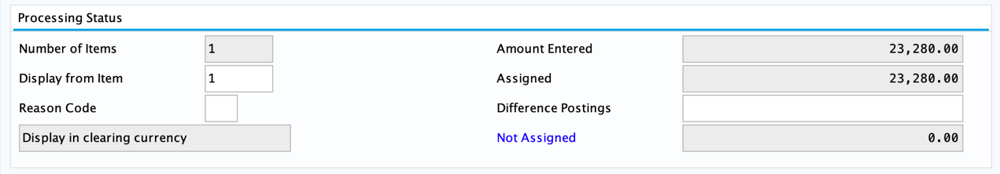

Final not assigned is **0**

**Step 17: Review Document Flow**

Double-click on the “not assigned” field and assign the number **23,249.06** to it. By clicking the post, the document is posted in company code DE00. The process of sales and distribution is now finished.

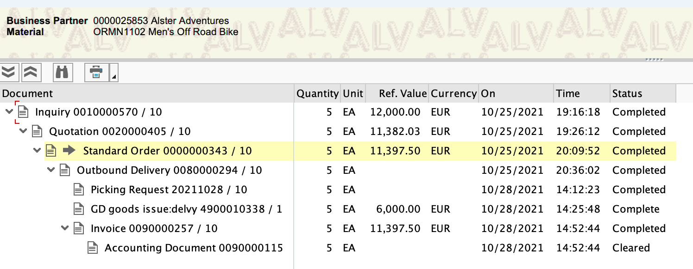

**Reflection on the SD challenge case**

During the practice of using SAP to complete the SD challenge, we had developed deeper understanding of how the data of different levels and departments are coordinated in the SAP system and found several interesting points. Our reflections as well as our further thoughts on the integrated sales and distributions process on SAP are summarized as the following:

1. Overall reflection: Integrate various modules, Enable an order-to-cash process

In the process of using SAP to complete the SD challenge, we have gained profound knowledge of SAP as a centralized system which assists businesses with data management. SAP sorts out data according to various departmental responsibilities and provides us insight of how the different departments cooperate through the sales and distribution process. Other than that, SAP also depicted how a single sector can branch out and be linked to various departments. For instance, we notice how SAP SD associated logistics with numerous other modules such as Material Management (MM), Production Planning (PP), Accounting Management and Human Resource (HR) which are all accessible by navigating through the SAP Easy Access Interface. To illustrate this further, according to Figure 1, if we want to check the stock status, we can find it through the route: Logistics-Material Management -Inventory Management-Environment-Stock-Stock Overview. Therefore, we now know how SAP can accelerate workflow, which reduces lengthy inter-departmental communication and as a result, enables work efficiency.

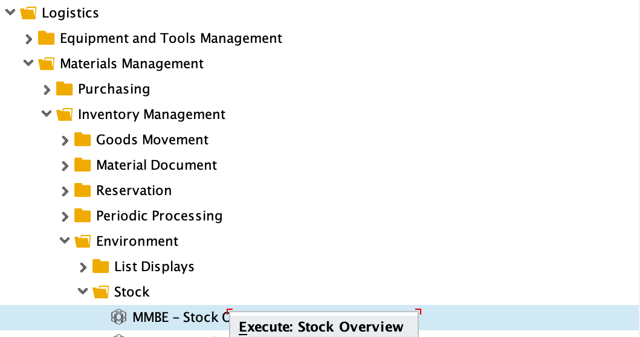

Figure 1

Additionally, we also get to understand and see the process of sales and distribution in practice. This process is regarded as an ‘Order-to-Cash Process’. The procedure of an order-to-cash process is described in Figure 2.

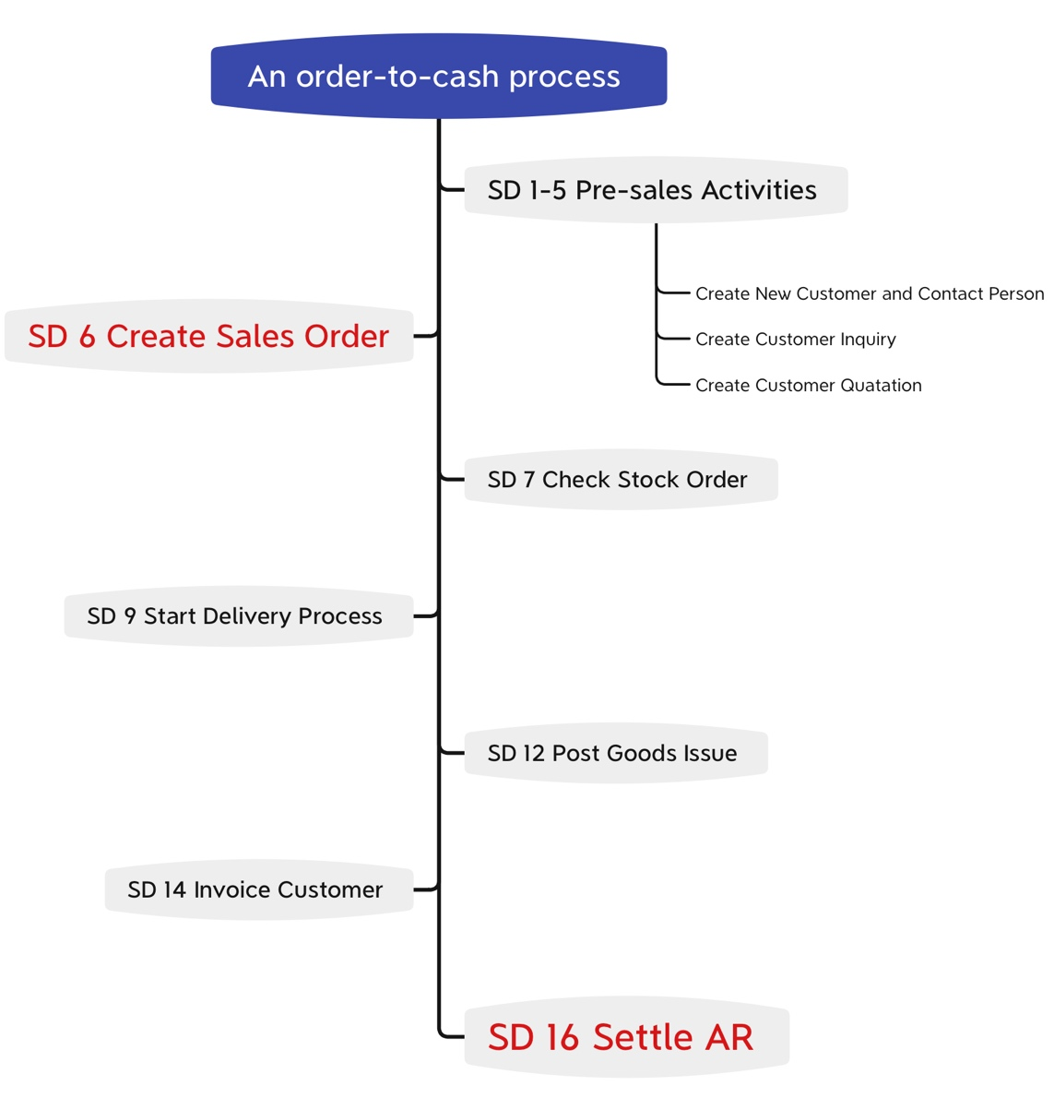

Figure 2

In a typical cycle, we first generate customer and sales quotations. Then a sales order is created to notify transports to pick up and deliver goods from the warehouse or production facility to the customer, with an invoice following up the order. Finally, the accounts receivable will be adjusted to settle the transaction between the business and the customer, which then, generates cash. In each step of the process, data are generated and recorded in various data departments. Hence, SAP has a complete record of the order-to-cash process, making it easier for employees to access when needed. From this procedure, we learn how inter-related everything is, and so we notice how important it is to deliberately follow the steps, otherwise, the entire transaction process will be affected.

1. The use of search term

We also discovered that ‘Search Term’ is a very helpful and important feature, which allows us to navigate through SAP conveniently. The ‘Search Term’ works by recognizing a series of data inputs categorized under the same search term and create a link between them. For instance, when creating BP relationship (Step 3), in order to appoint a contact person to a certain customer, we must build a relationship between the customer data (Step 1) and the contact person data (Step 2). We do this by using the same search term to reference both the contact person and the customer as shown in Figure 3. Thus, we can easily find both the customer and their corresponding contact person by using the ‘Search Term’ feature.

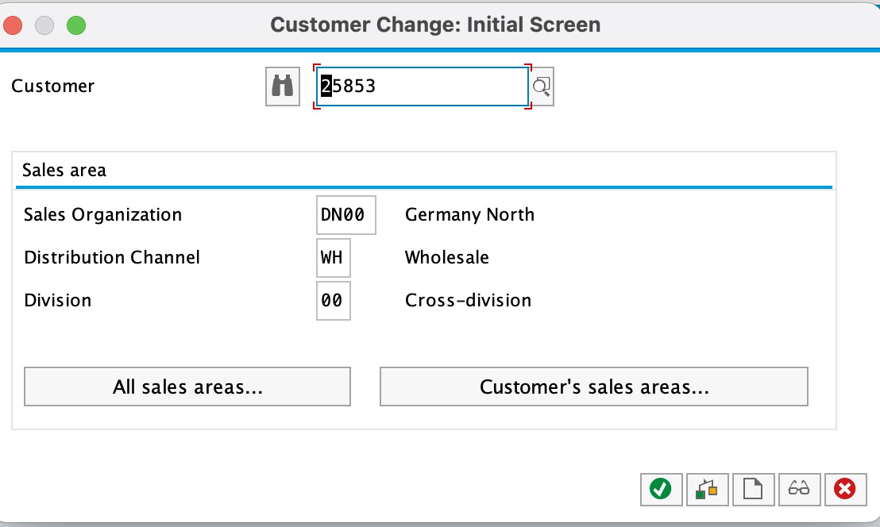

Figure 3

Furthermore, ‘Search Term’ can also retrieve the data of the previous level and call the next data operation. Throughout our lectures and seminars, we have come to realize the importance of data hierarchy and order. It is only when the upper-level data is defined, could the lower-level data be checked and be inputted correctly. The data hierarchy can be seen in Figure 4. The search term is often used to retrieve the data from the upper level. For example, if we want to check the status of the inventory, we should use the search term to retrieve the specified data at the organizational level including sales organization, distribution channel, and division (Figure 4 shows the challenge situation) and the specific plant data to perform correctly. Overall, the discovery of the ‘Search Term’ has been very intriguing to our group. Not only does the ‘Search Term’ help us understand the data structure in SAP, but its various ways of utilization have also proved to be very helpful to our learning experience.

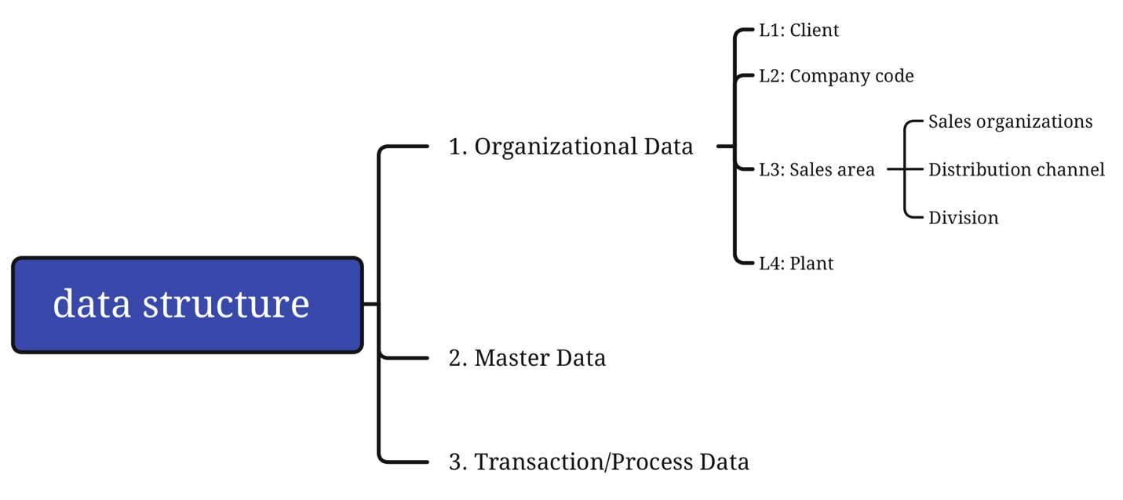

Figure 4

1. Thoughts on stock status situations

When performing the step 13 ‘Check Stock status’, we followed the steps to check the inventory quantity of the men off-road bikes which is shown as 95. Since the order only requires quantity of five, the number of goods in the inventory is more than sufficient to fulfill the order.

However, we are interested to know, if the order quantity exceeds the inventory’s, how would the SAP system deal with it? After a while, our thoughts finally led us to conclude this question with these scenarios.

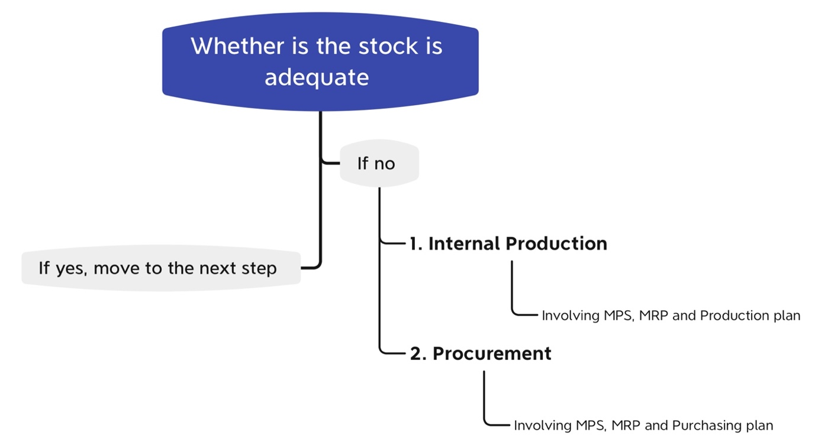

Figure 5

As shown in Figure 5, if the inventory is inadequate, the first step is to notify the production department to produce internally, which may involve Master Production Schedule (MPS), Material Requirement Planning (MRP) and Production Plan. The second is to conduct procurement process, which also includes MPS, MRP as well as the purchasing plan. With our current knowledge, further procedures are too complicated for us to perform. Although we are interested to know the solution to this issue, further study in SAP might be needed before we can solve this problem.

**Problems**

1. Problems in team coordination

Our group had encountered some problems with our time arrangement. Firstly, it was because we had very limited time to complete our report before the deadline. Other than that, our group members were all inexperienced with SAP, making it hard for us to smoothly and quickly execute the challenge. Additionally, it was hard to arrange our time because of the time difference we had with our international teammate. Therefore, we had to organize a meeting time that is suitable for all our different schedules. The team leader has also assigned reasonable task allocations for each of us to work through the challenge efficiently. It was indeed a challenge for us to understand the operation of SAP system in a short time. The case study and challenge guideline helped us a lot.

1. Problem about the SD challenge

Firstly, the seminar time was limited, so each group member only completed the first few steps of the SD Case. In other words, we had insufficient knowledge and understanding of how SAP operates. Thus, it has caused great difficulties for us to start the process. Moreover, some details were not given directly in the SD challenge description such as the customer’s personal information. Although this challenge was similar to the SD case, its scenario contains much more information than what we were given in previous cases and thus, we find it to be an obstacle to navigate through this challenge. We were bogged down by the steps to completing the challenge. Fortunately, after discussion among our group members and with the help of our teacher, we were able to solve most of the problems. Here are some steps that we have struggled to do during the challenge:

* Step 1: When filling in the parameters for billing and shipping, we were confused because different details were given in the challenge compared to the previous seminar case.
* Step 4: We got stuck in this step for a long time because we did not know the meaning of ‘Order Probability’. Due to this, we decided to use the default parameter 30, which then led to an error in the subsequent steps.
* Step 5: Here we were required to fill K004 in the column corresponding to both ‘Woman Off-Road Bike’ and ‘Man Off-Road Bike’. But at first, we only filled it in once. Asides from that, we were also doubtful about this parameter because in the previous case given in the seminar, we used K005 instead of K004 and we did not know the difference between these two parameters. Additionally, according to the scenario that the off-road helmet is free so that we should fill AGNN, but we forgot to do that.
* Step 16: We encountered difficulties at the beginning of this step which prevented us from proceeding. After reworking the challenge, we found that the reason for the error was that we had not selected the ‘pick quantity’ for scheduled delivery option.

**FI REPORT**

**Main Steps and Execution Results**

**Step 1: Create Bank Account in General Ledger**

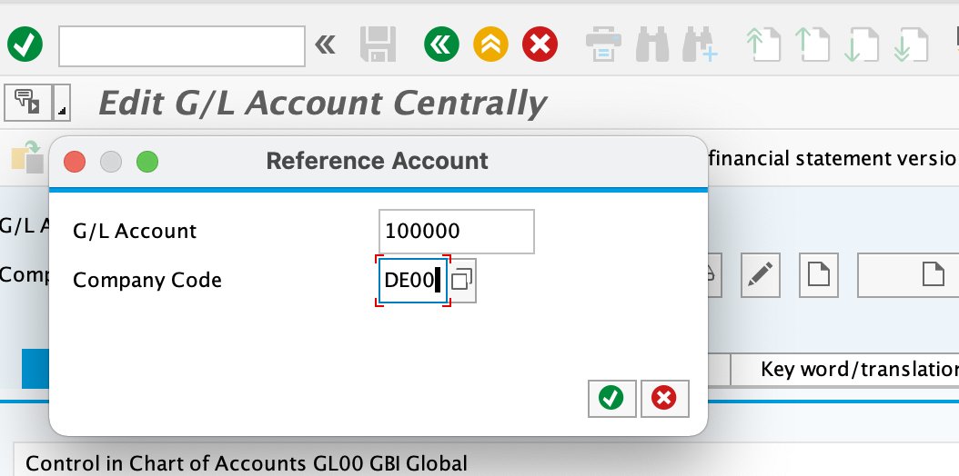

Enter the G/L account and company code.

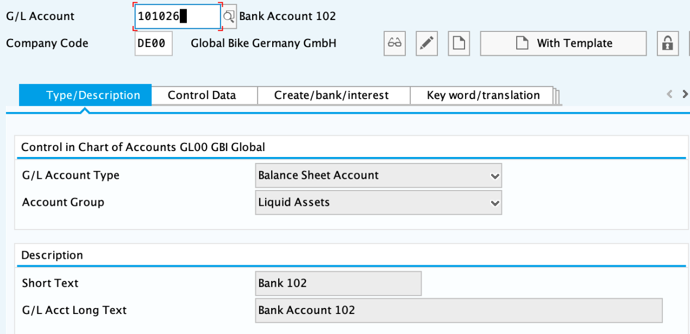

The short text is Bank 102, and the G/L Acct Long Text is Bank Account 102. Then click on save.

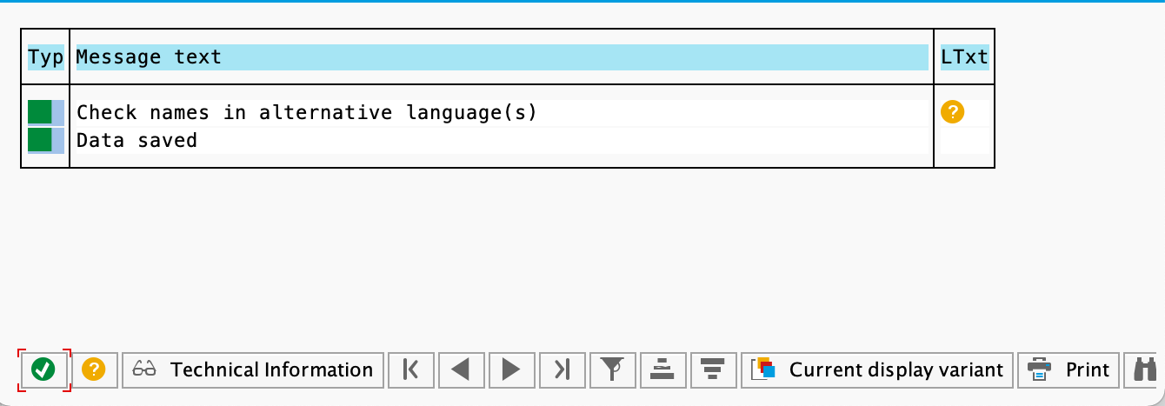

Finally, this pop-up window is displayed.

**Step 2: Create Reconciliation Account in General Ledger**

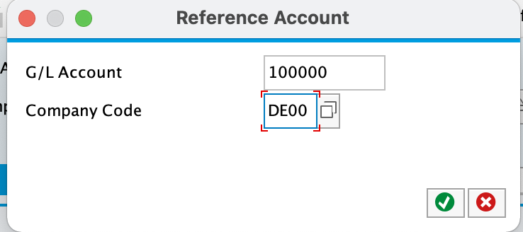

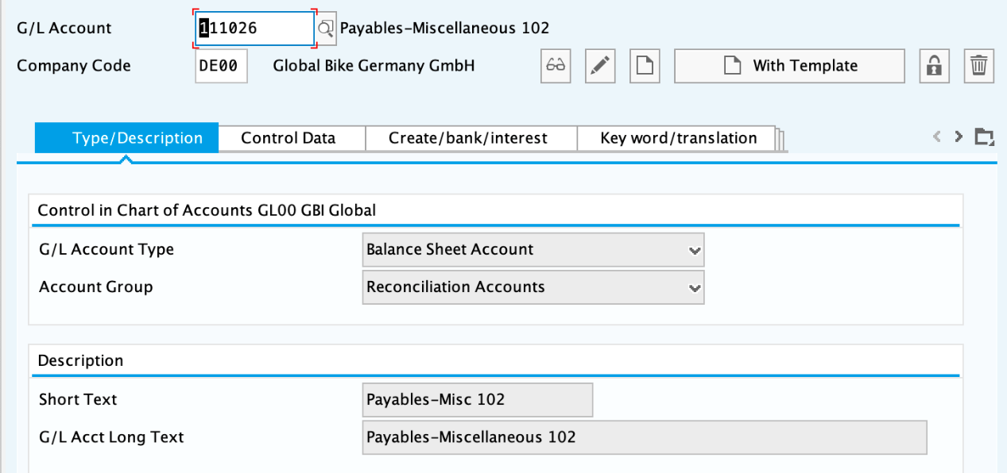

Fill in Short Text with **Payables-Misc 102** and G/L Acct Long Text with **Payables-Miscellaneous 102.**

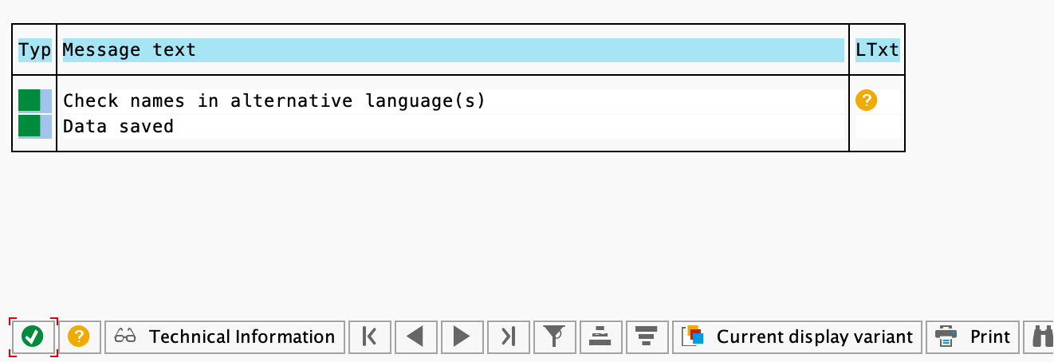

After completing the above, this pop-up window is displayed.

**Step 3: Create Expense Account in General Ledger**

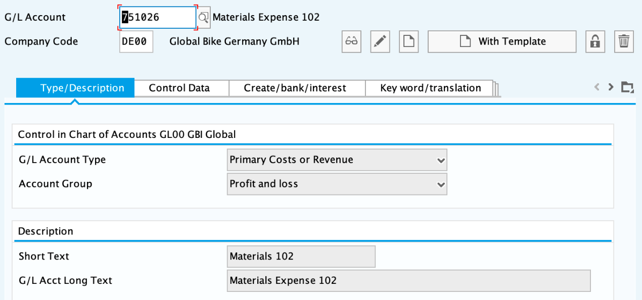

Take **Materials 102** as short text and **Materials Expense 102** as G/L Acct Long Text.



**Step 4:** **Create Cost Element for Expense Account**

This step is exactly the same as the previous one, so skip this step and directly proceed to the next.

**Step 5: Post Transfer of Funds to Alternate Bank Account**

Type current date as document date, and fill **102** as reference, **Transfer of Funds** as Doc.Header Text.

On the first row, fill **101026** in G/L acct, **5000** as amount in doc.curr, and select **Debit** as D/C.

On the second row, fill **100000** in G/L acct, **5000** as amount in doc.curr and select **Crebit** as D/C.

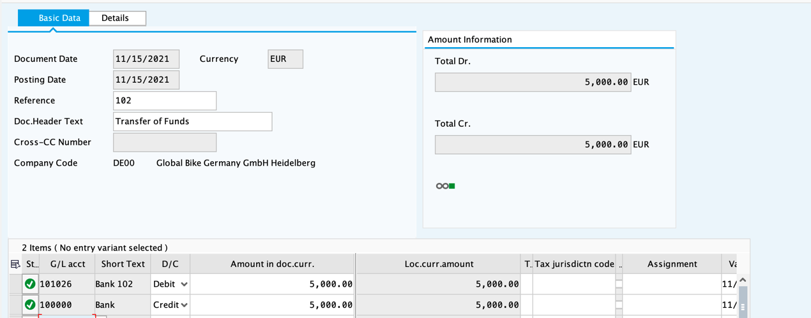



**Step 6: Create Invoice Receipt for Rent Expense**

Type **113102** in Vendor, current date in invoice date, **3000** in account, **Invoice PC-102** in text. Fill in G/L acct **751026**, **Debit** D/C, account in doc.crr. **3000** and Cost center **EUPC1000**.

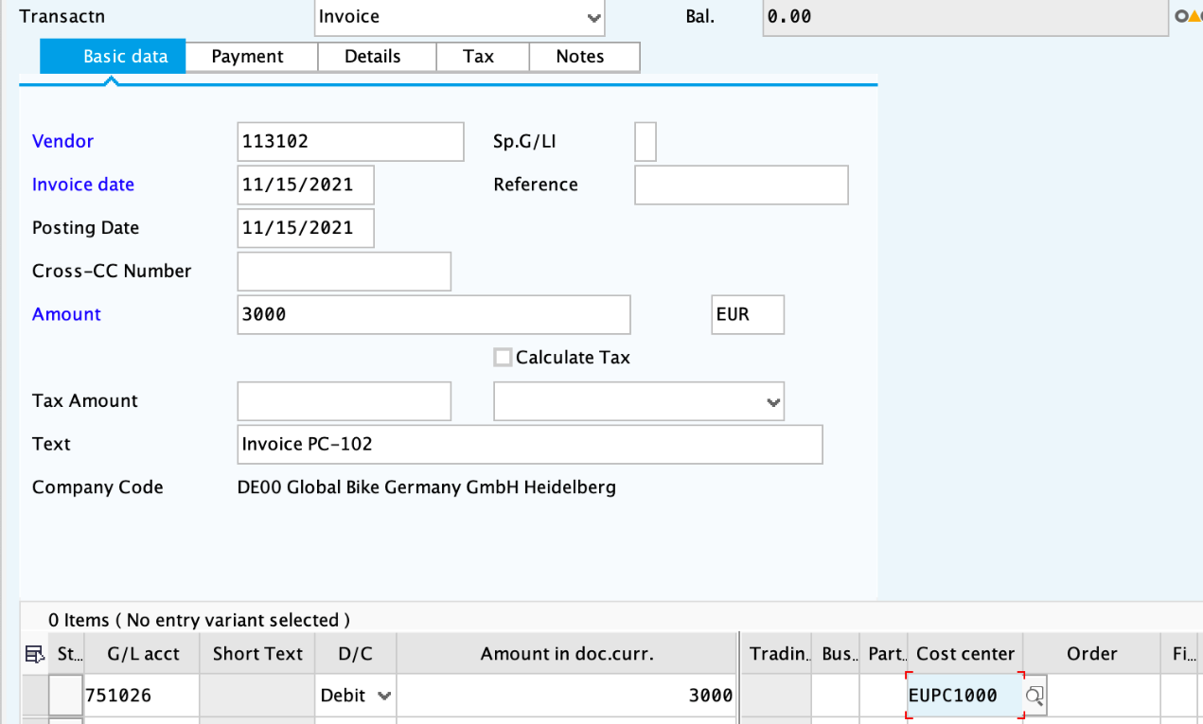

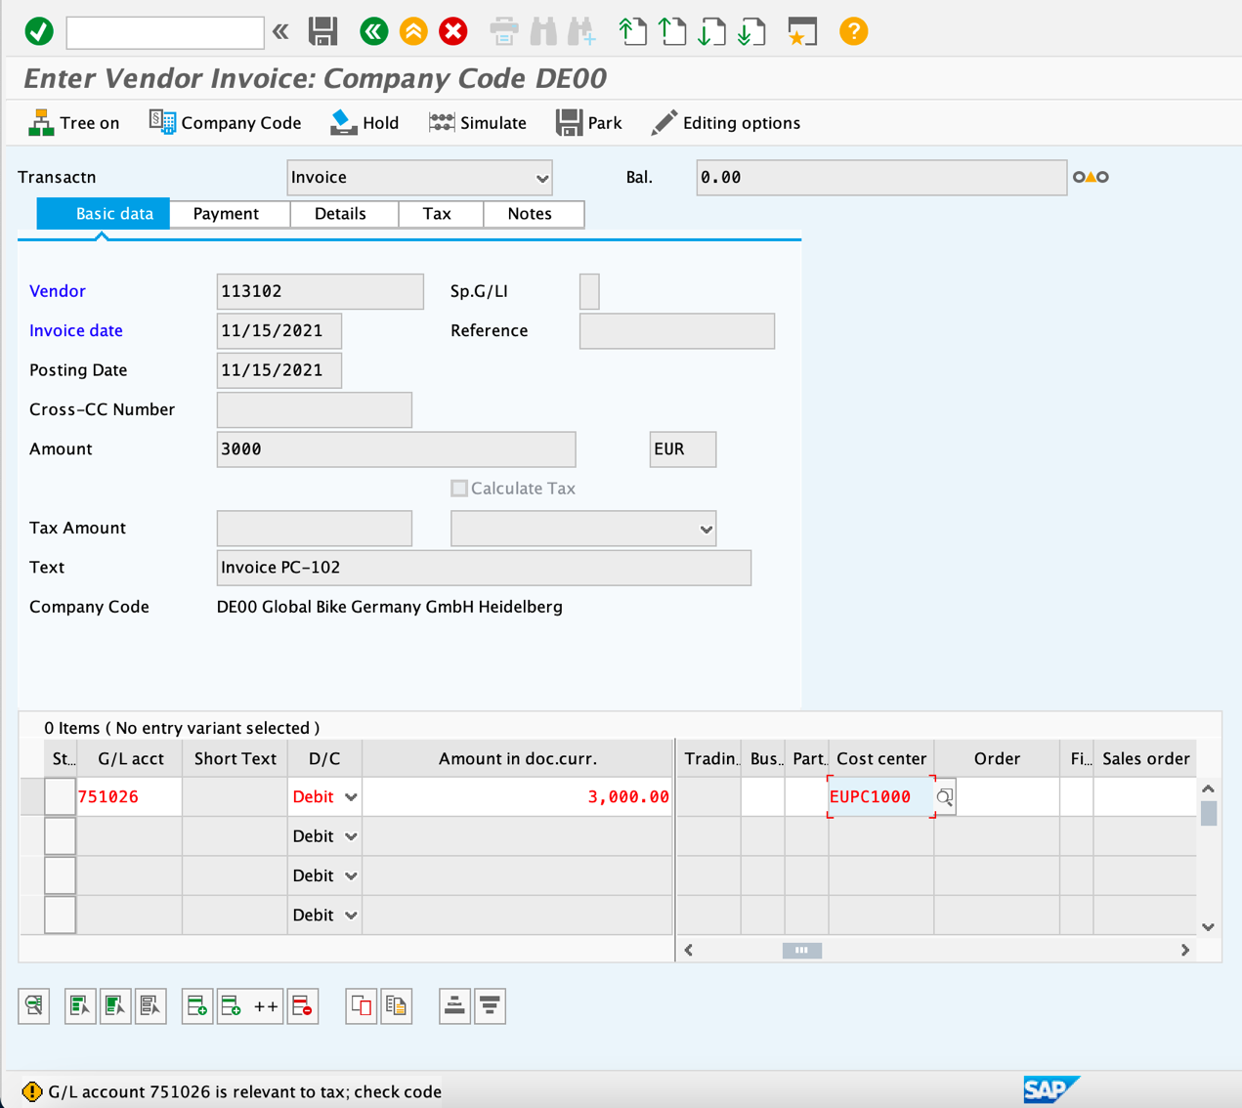

Confirm the warning message by clicking Enter. Click stimulate to check the posting. Then click Post button, which is the Enter button.



**Step 7: Post Payment to Vendor**

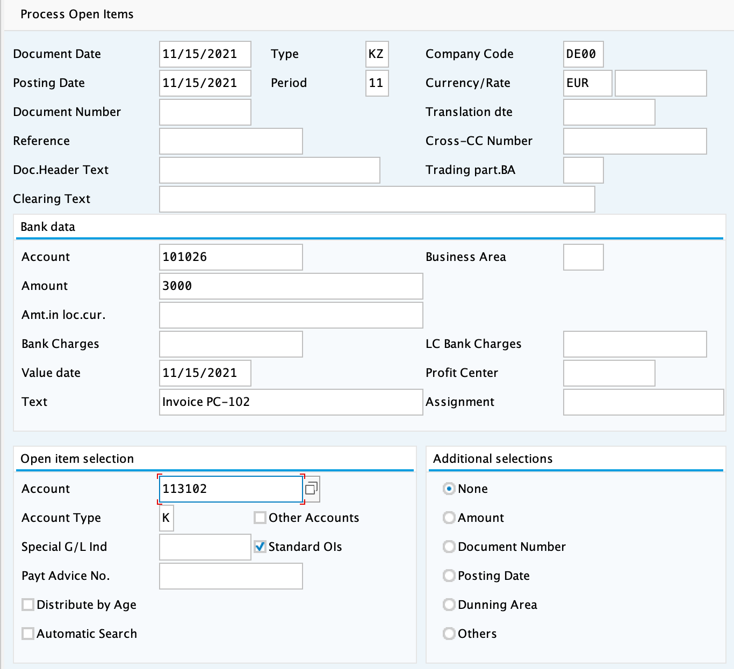

Document date is the current date, and bank account is **101026**. Enter **3000** in amount, **invoice PC-102** in text, and vendor number **113102** in account.

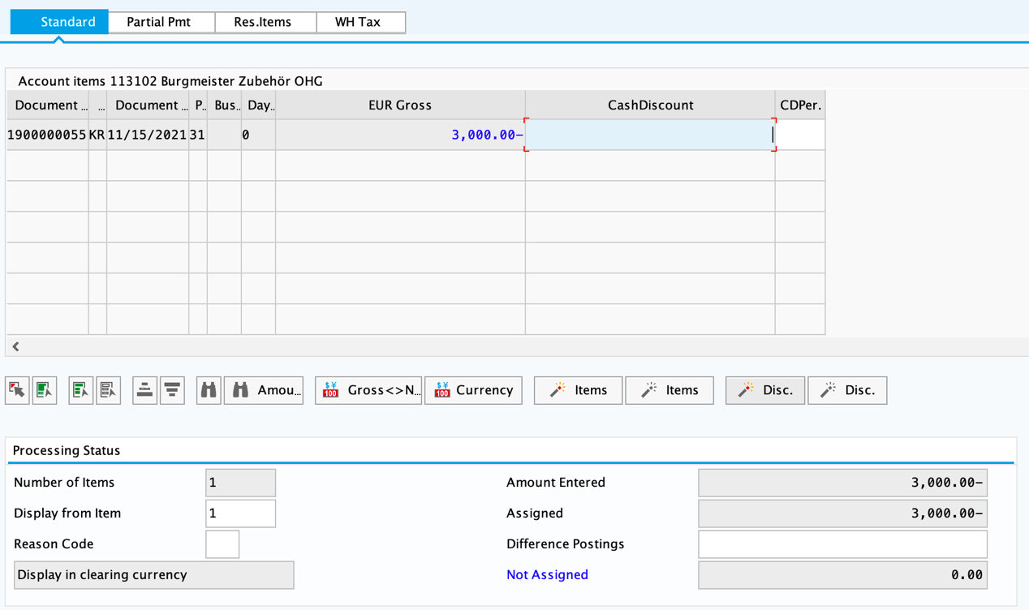

It is supposed to be ‘Not assigned’ when the corresponding value is **0.00**.



**Step 8: Run Financial Statement**

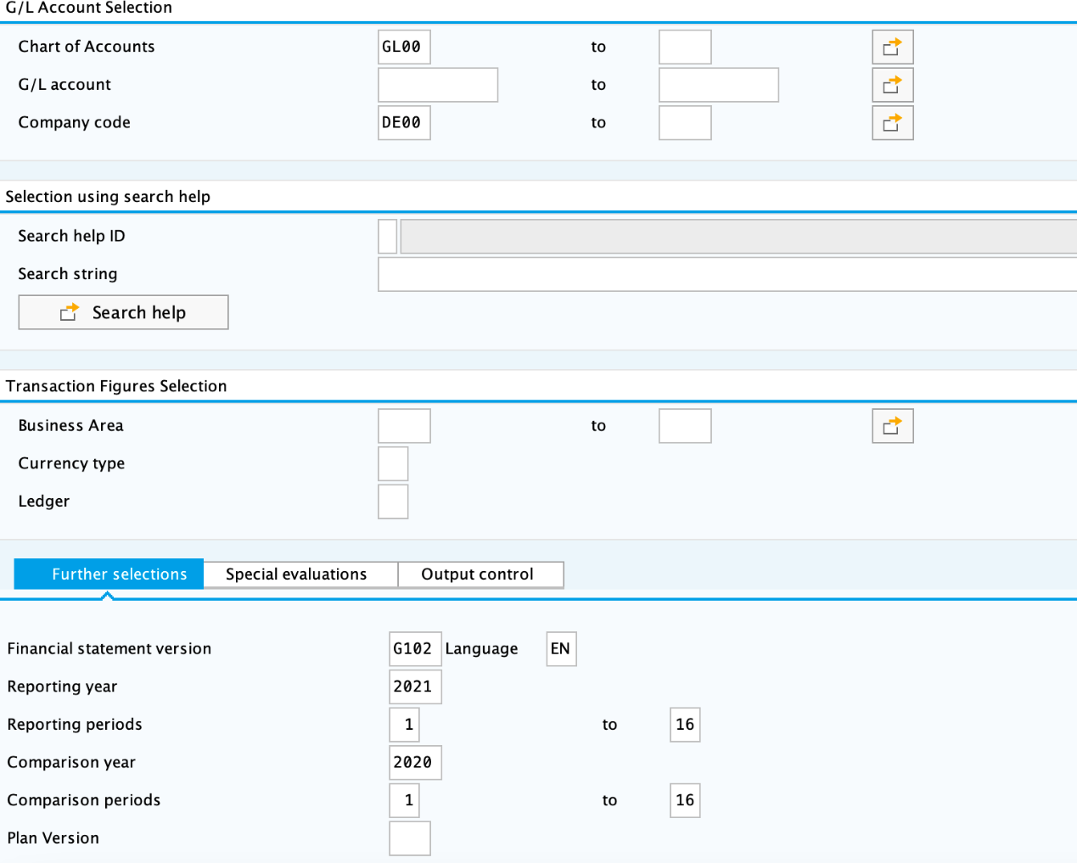

**GL00** is entered as Chart of Accounts and **DE00** is entered as company code. Then **G102** is entered as financial statement version and set current year as reporting year.

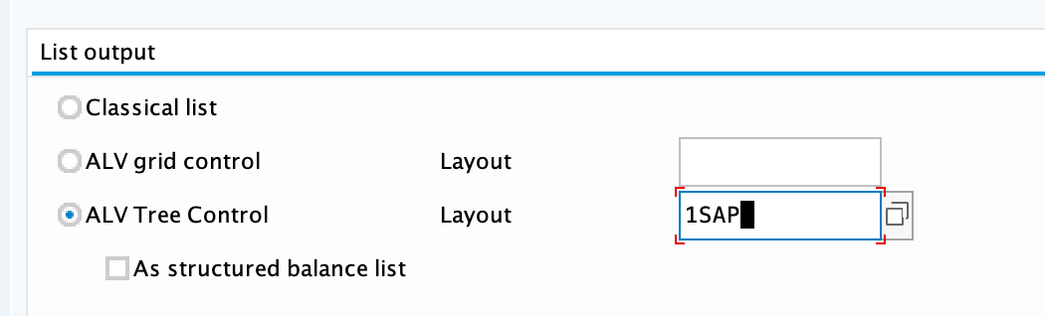

Choose **ALV Tree Contro**l, and fill **1SAP** in layout.

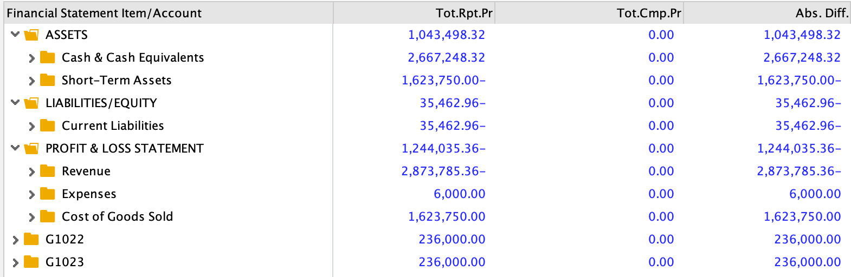

**Reflection on the FI challenge case**

During the FI challenge, we were able to develop a deeper understanding of how the process of financial accounting is done in a company through SAP system and found several interesting points. Our reflections on the challenge on SAP are summarized as the following:

1. Overall refection

Overall, the process of FI was relatively easy for us since we had more experience from former challenges (i.e., MM and SD). Furthermore, we are now more familiar with the layout of SAP, which allows us to locate its features easily. As shown in Figure 1, we firstly began the FI challenge by creating accounts in the General Ledger (GL) such as the bank account, reconciliation account and the expense account. Then, we posted the transfer of funds to the Alternate Bank Account and reviewed it. Before adjusting accounts payable, we created an invoice receipt for the rent expense which then we displayed. After a final check, we post the payment to the landlord. Finally, the FI challenge was completed by running the Financial Statement.

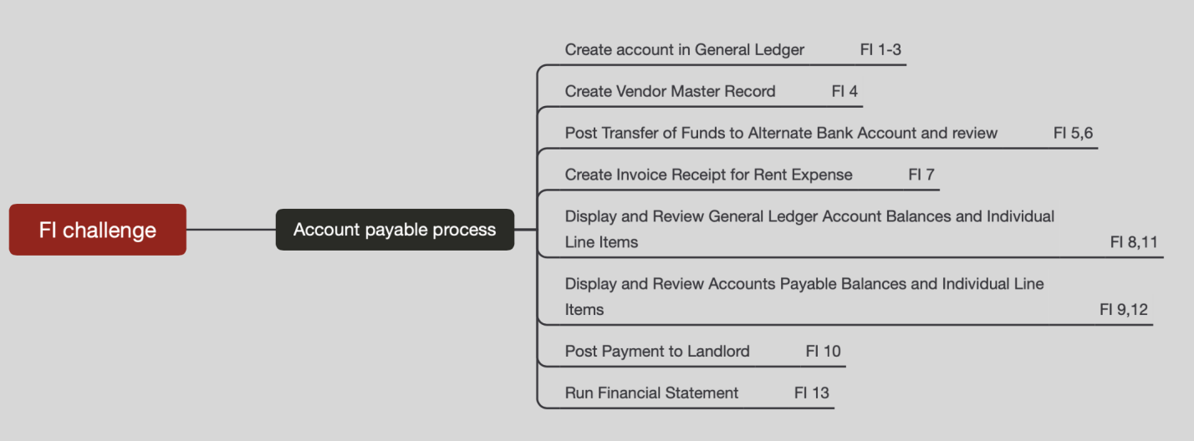

Figure 1

1. Document flow of FI process

Throughout the completion of the FI challenge, we learned how the transaction data transfer were recorded, and ultimately understood how everything is connected in the system. The FI challenge has demonstrated the process of purchase, which is illustrated by the T-accounts as shown in Figure 2. When the purchase of tools from ***Burgmeister Zubehör OHG*** occurred, it will firstly be considered as a **tool expense** of 3000€ which will be recorded in the profit and loss account. Simultaneously, the invoice receipt will be created: 3000€ is also recorded into the credit side of **Burgmeister Zubehör OHG sub ledger account.** Then,the system will automatically input the same figure into **Account Payable general ledger**. After paying the Account Payable successfully, our **bank account** will have a total credit of 3000€ since 3000€ has been paid out to the ledger. Meanwhile, there will be 3000€ debit on the **General Ledger account** because of the settlement of AP.

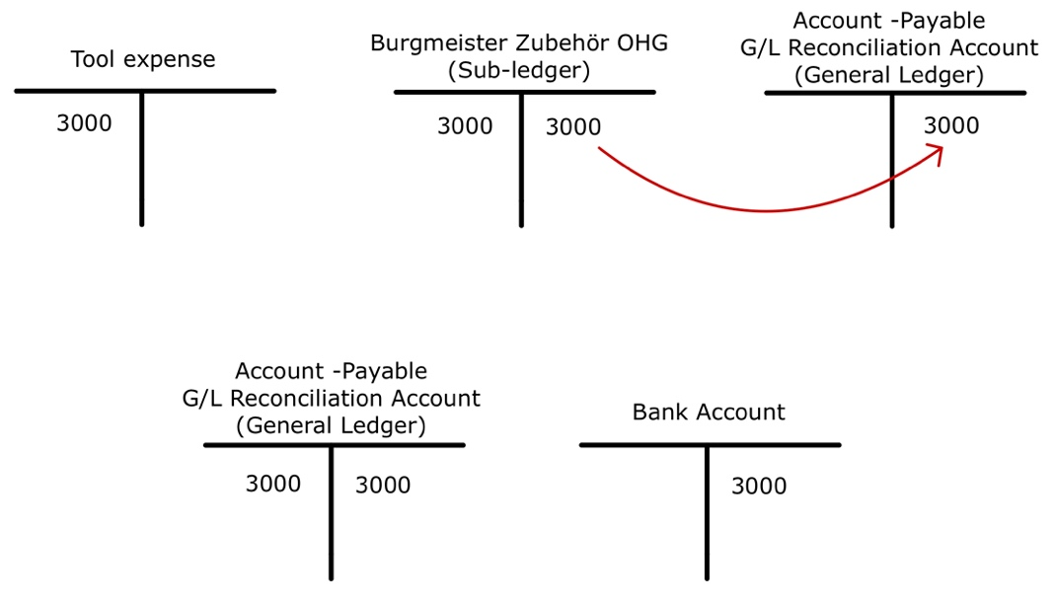

Figure 2

1. How to deal with the bad debts

So far, we have only dealt with accounts payable in the FI challenge; however, it is obvious that in the real financial accounting process, we will come across more complicated problems which will require us to deal with different accounts. For instance, in real life, we may encounter customers that struggles financially. As a result, they may not be able to make their payment in time. This will be what we consider as a “doubtful debt” which might eventually turn into a “bad debt” in financial accounting. Thus, we are interested to know how the SAP system deal with the bad debts account. What information will be required and how will the system record and utilize it?

In order to prevent this situation from arising, we think that companies need to create measures for unexpected situations as such. One method to prepare for this kind of issue will be to do a background check on the customers before their purchase. This investigation will include checking the customer’s past payment record. If their record implied a bad payment history, the company should refrain from continuing the transaction with this certain customer. Another approach to this issue might be to prepare a provision for doubtful debts (PDD) in case the other measures failed to prevent this scenario. These method of identifying risky customers and preparing a PDD prior to the transaction could reduce the occurrence of bad debts and minimize possible causality caused to the company.

1. How about employee loan payments?

The scenarios in the FI case study and challenge are both about financial accounting of business transactions. However, sometimes, companies need to provide loans for their employees. We assume that there are two approaches to record employee loan in FI. Firstly, because each employee loan is accounted individually, we can treat these employees as vendors. Logically, we can also use a special GL transaction which will record the loan along with its respective employee. Then, a payment transaction will be made to initiate the loan, which then will trigger an adjustment in the amount of account receivables and its relevant bank account. In the second method, we can dispense loans to employees via payroll and post them to the special GL accounts in FI. This will require an integration between both the HR and FI module, but since we have not learned regarding the HR system, we may need further research before solving this problem.

**MM REPORT**

**Main Steps and Execution Results**

**Step1: Create material**

Since the suppliers have not changed, the step of creating a new supplier is not necessary.

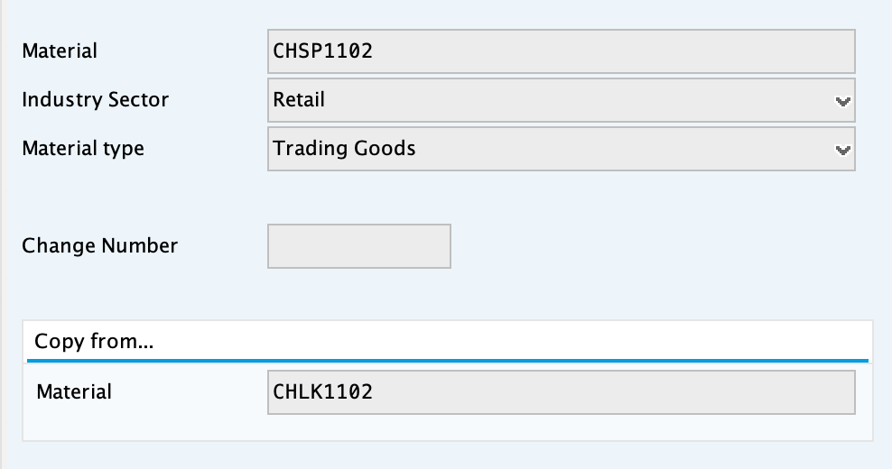

We create a new Security Chain Lock. The material is CHSP1102, industry sector is retail, and the material type is trading goods. Additionally, according to the scenario, the information can be copied from the old chain lock (CHLK1102).

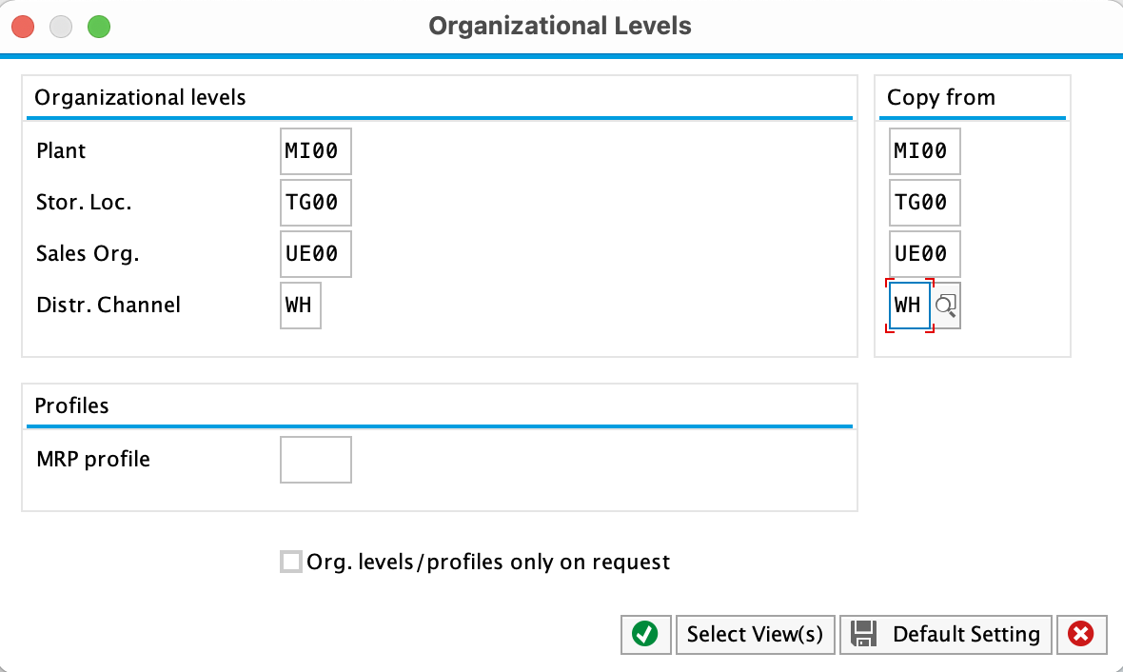

Now the new chain lock has the same characteristics as the old one.

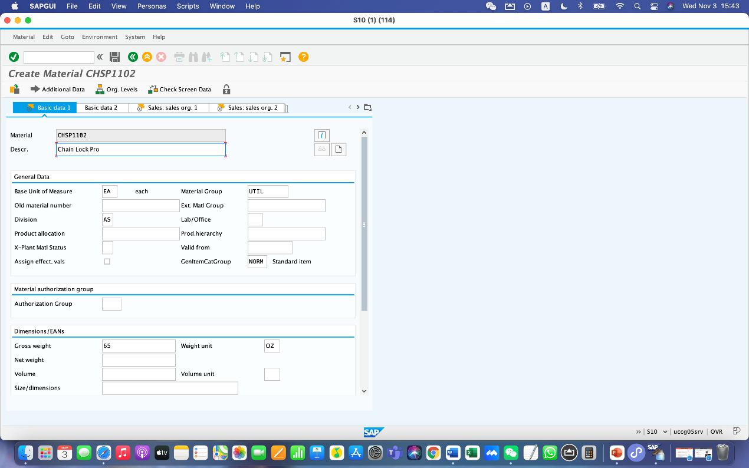

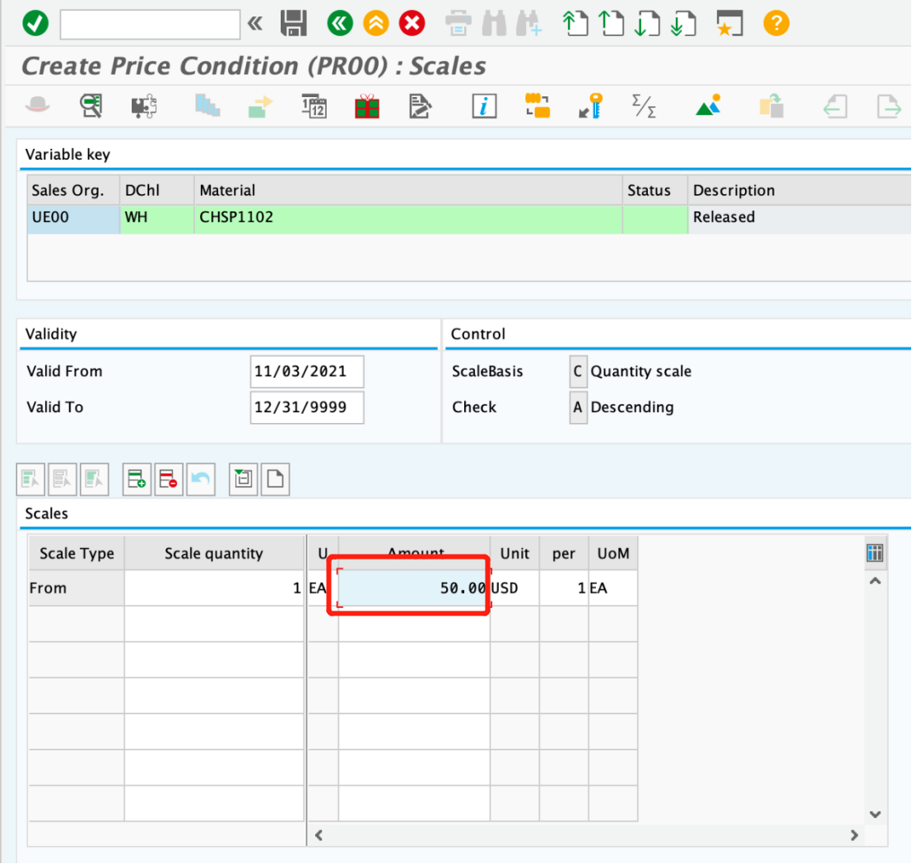

Then we change the material short text to Chain Lock Pro and set the scale quantity to 1 and the amount to 50.

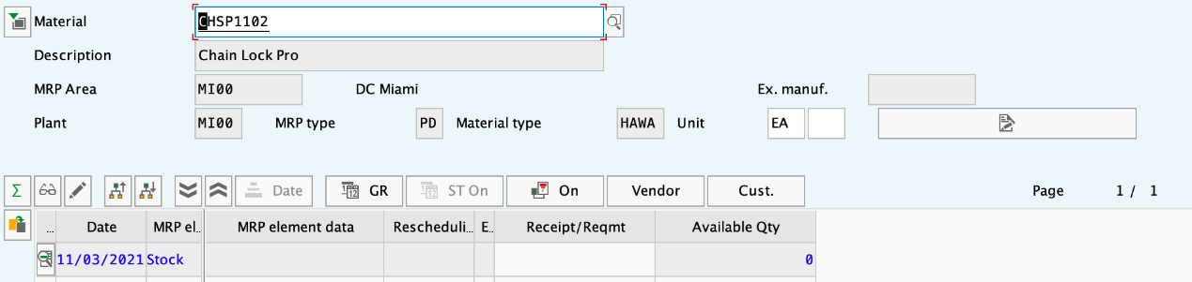

Then we display the stock/requirement list.

**Step 2: Create purchase requisition**

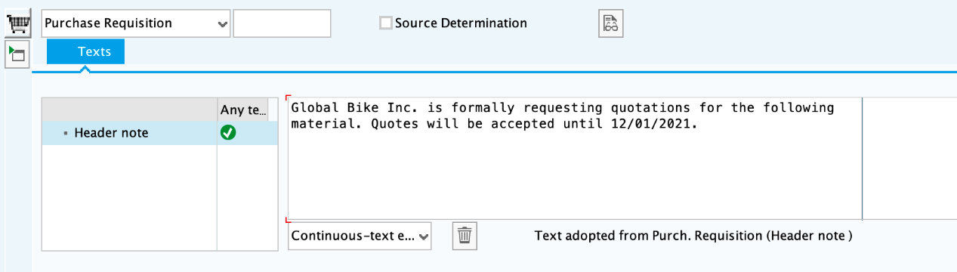

We filled in the header note.

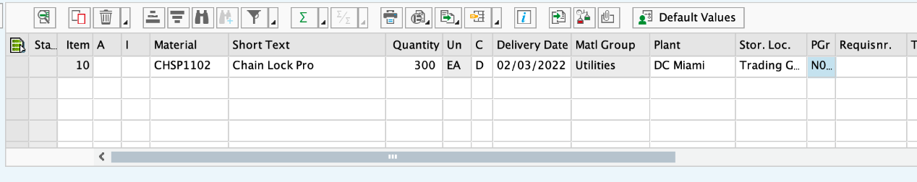

Filling in the information of the purchase requisition. Enter material CHSP1102, short text is Chain Lock Pro, and quantity is 300. The delivery date is 3 months from today, so it is 02/03/2022. Then enter MI00 in the plant field, TG00 in Stor.Loc. field, and N00 in PGr. Field.

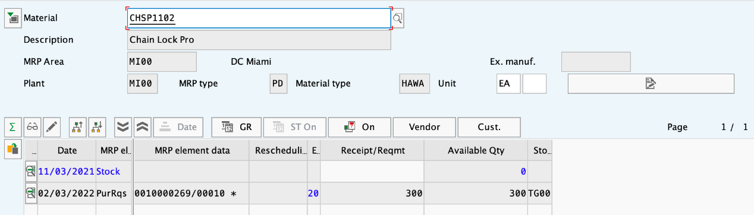

After that, we display stock/requirements list.

**Step 3: Create request for quotation**

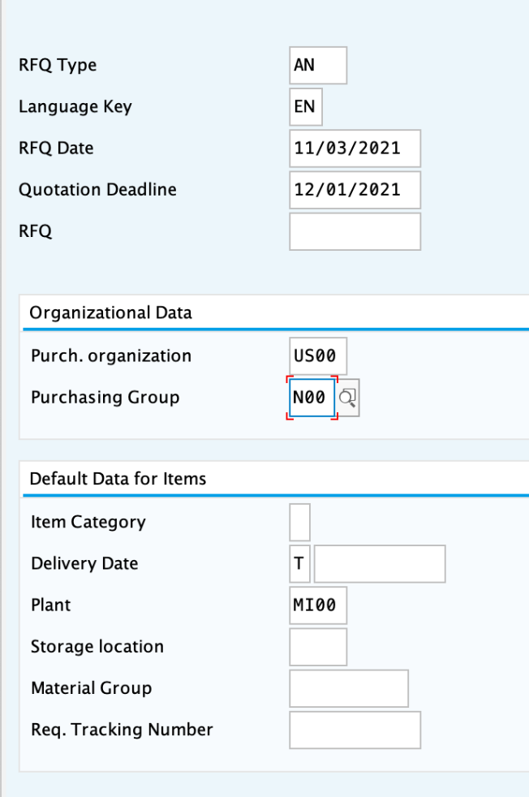

RFQ type is AN, language key is EN, and RFQ date is today(11/03 2021). Because the quotation deadline is the first day of next month, enter 12/01/2021 in the field. In the organizational data field, enter the Purch.organization US00 and N00 as Purchasing group. After this step, we filled in plant with MI00.

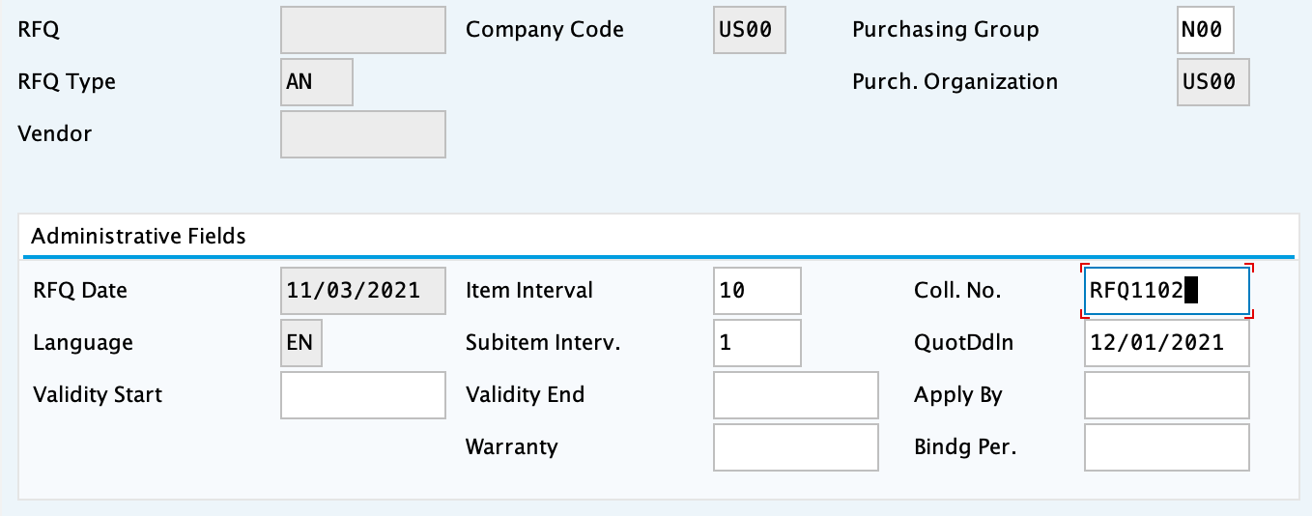

**Step 4: Maintain quotations from vendors**

For Boomtown

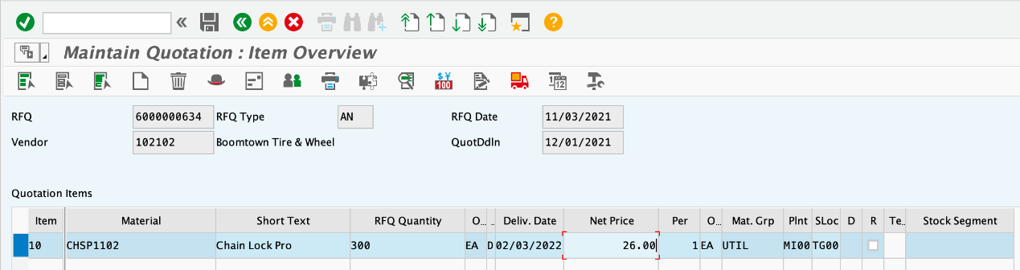

Enter 26 as net price.

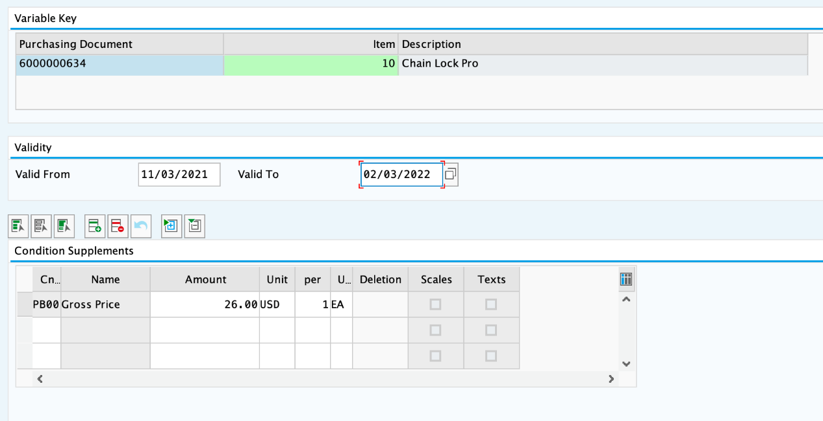

Set the valid to data to three months from today.

For Space Bike

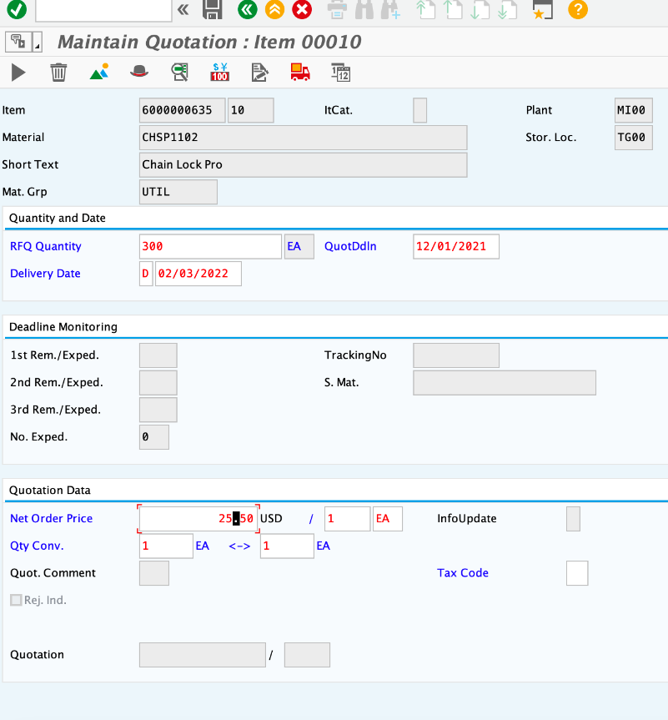

This process is the same as above. The net order price is 25.50 USD.

**Step 5: Reject two quotations**

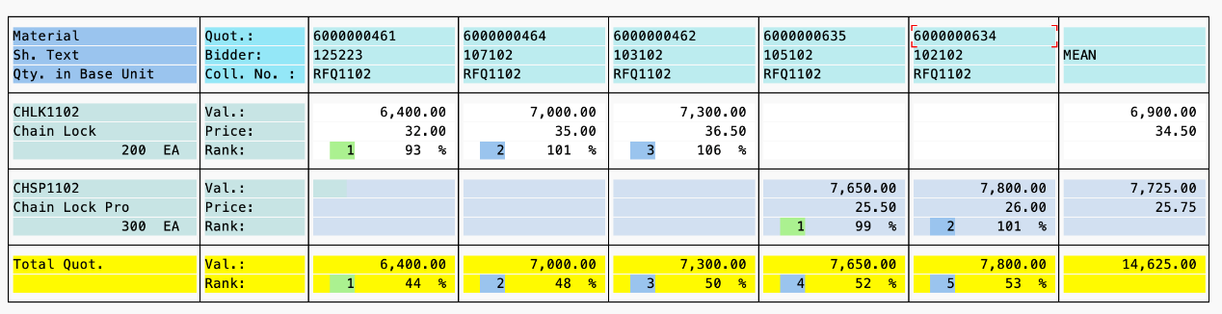

Double-click on the quotation number with 26.00 USD.



Select Rej.Ind. to indicate rejection of this quotation.

**Step 6: Create purchase order referencing an RFQ**

As selection variant choose **Requests for quotations.** On the Material Number select Material CHSP1102 in the Material Number field and make sure other fields are empty. Then execute.

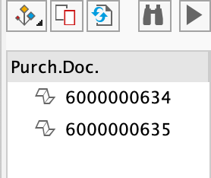

**select vendor name**

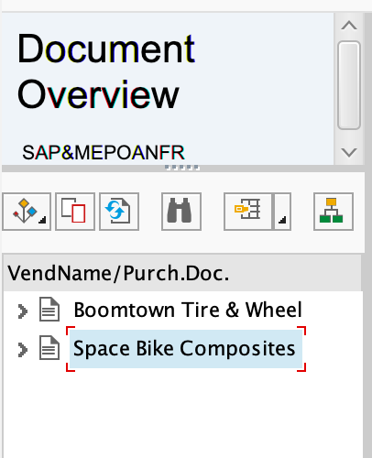

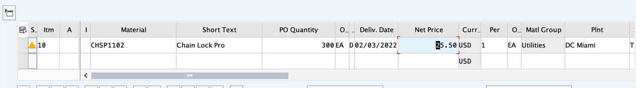The system copied the Material number **CHSP1102,** Quantity **300**, **three months from today** as Deliv. Date, and the Net Price of **25.50 USD**.

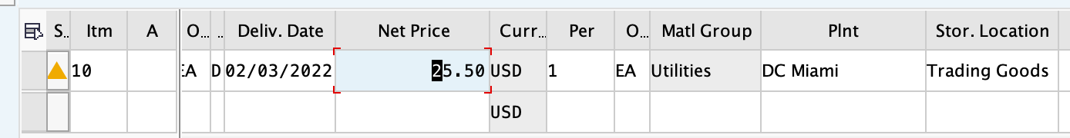

Standard PO created.



**Step 7: Create goods receipt for purchase order**

Select **Goods Receipt** and **Purchase Order**. Enter PO number 4500000171. Then, check **OK**. **Trading Goods** should already be existed.

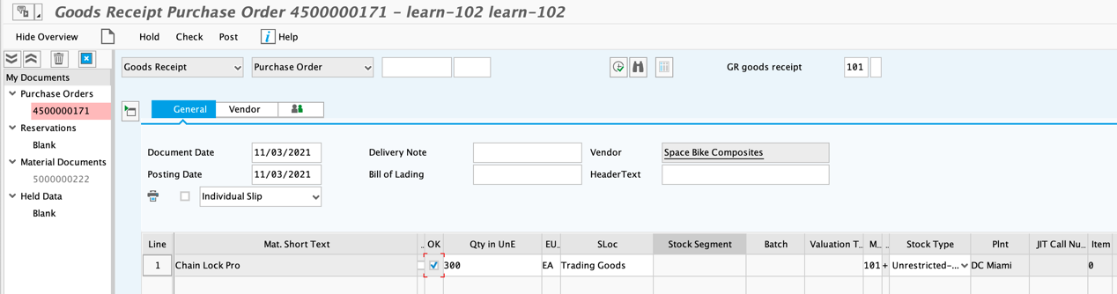

The system create a goods receipt document(5000000229).

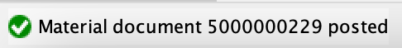

**Step 8: Create and post an invoice**

Type in **11/03 2021** as Invoice date, **US00** as company code**, 7,650.00 as amount,** choose **XI** as Tax Code, type **INVOICE 00504-102** as text and enter PO number **4500000171**.

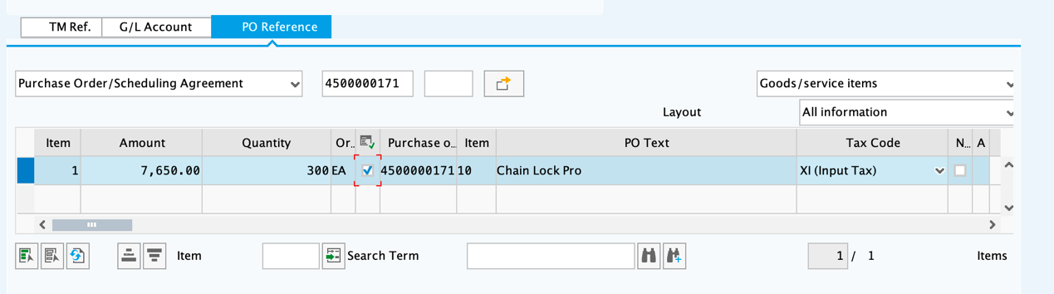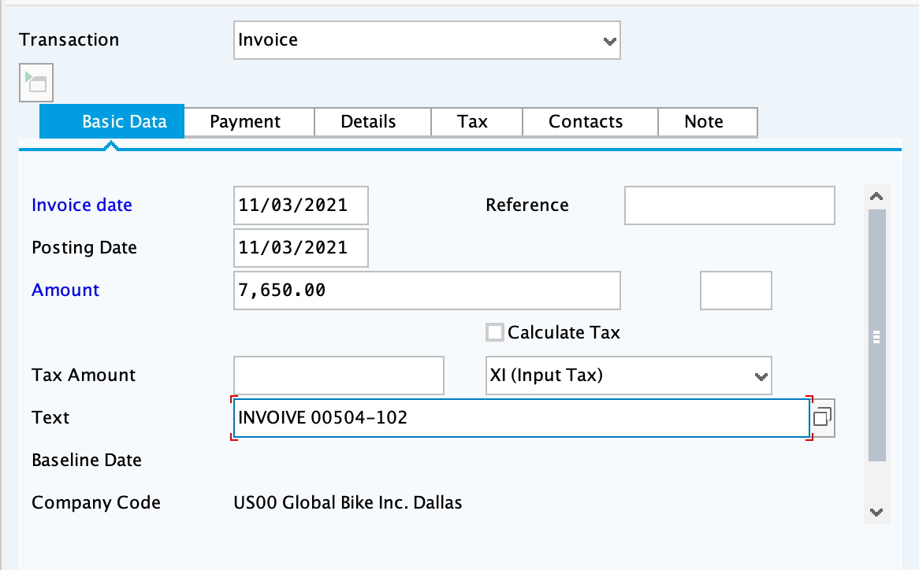

Input PO number 4500000171



Click the button **Stimulate** to check the accuracy of the postings.

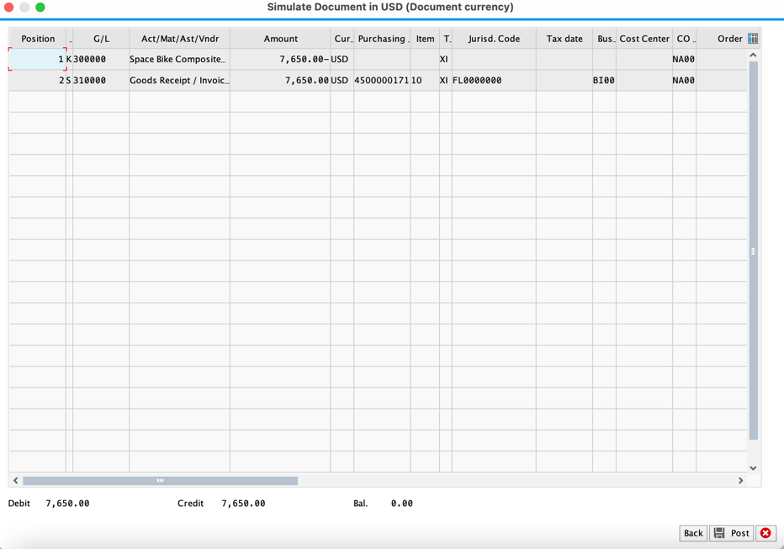

After checking, **Post** it, then a document number(**5105600292**) is created.



**Step 9: Post outgoing payment**

Enter **11/03 2021** as Document Date, **100000** in Bank Account, **7,650.00** in amount field. Text **INVOICES 00504-102.**

In the account field of Open item selection, input **105102,** which is vendor number of Space Bike Compositesvendor

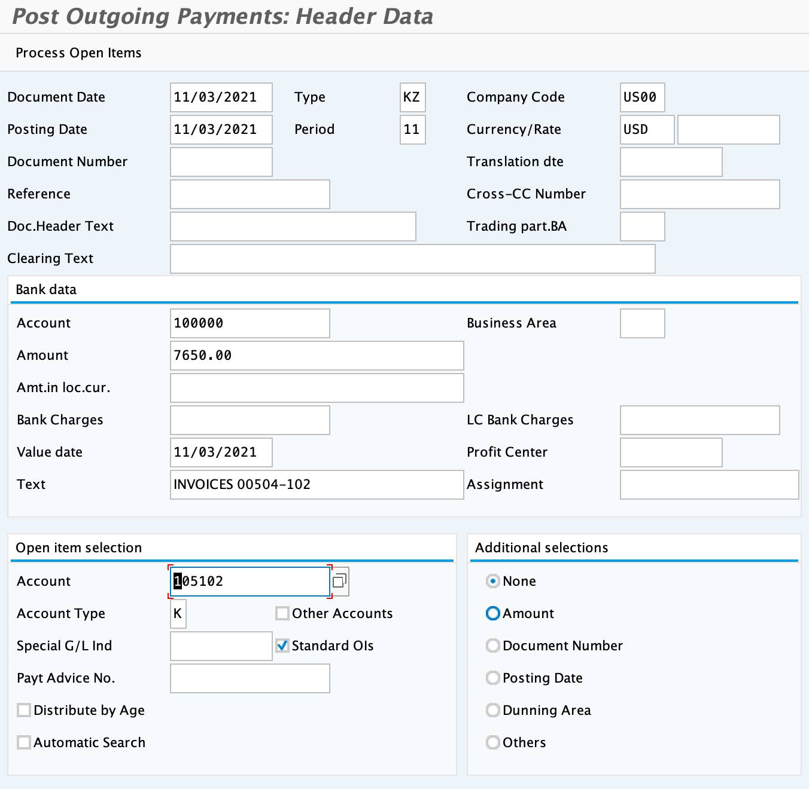

A vendor payment document number is created, which is 1500000099.

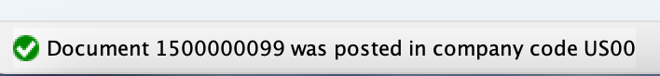

The total amount has been entirely assigned.

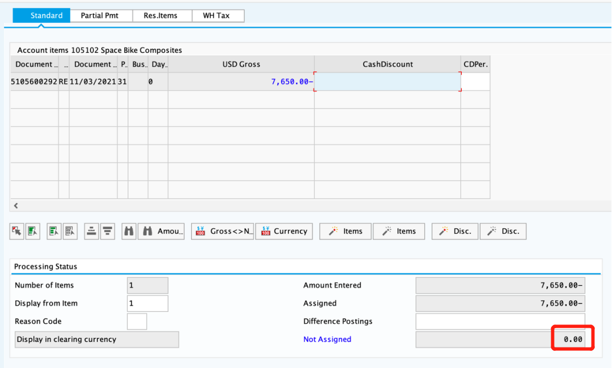

**Reflection on the SD challenge case**

During the MM challenge, we were able to develop a deeper understanding of how the process of materials purchasing is done in a company through SAP system and found several interesting points. Our reflections on the materials purchasing process on SAP are summarized as the following:

1. Overall reflection

In general, the process of completing the MM challenge went smoother compared to the SD challenge since we are now more familiar with the SAP. We learned how to integrate MM and FI in this challenge which involves dealing with organizational data, master data and transaction data. Moreover, we also learned the importance of master data in the SAP system which includes information regarding the vendors, materials, and purchase process.

In the purchasing process, we firstly decide which materials we need to obtain by checking our stock list. After that, we create purchase requisition to request our department to initiate our purchase of materials or service. Then we select vendors according to their quotation price assuming that the quality of the products are roughly the same. Following this, we create a purchase order with reference to RFQ. After the goods receipts are created, the materials will then be sent from the vendors to the company for further quality inspections. After deciding that the goods meets the company’s standards, the company will then release the payment to respective vendors (seller) and thus, reconciliation of the invoice and PO is accomplished. Finally, the process is settled with an adjustment in accounts payables.

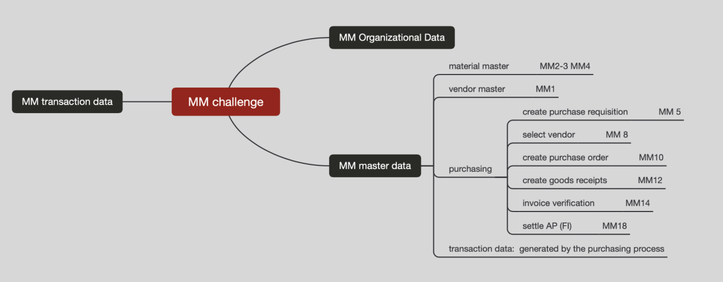

Figure 1: MM mind map

1. Evaluation criteria on quotation

When performing step 9 ‘Evaluate quotations on price’, we tend to choose vendors that offered us the lowest prices, assuming that the quality of all materials are equivalent despite the varying prices. However, this situation is often unrealistic. Afterall, it is a common perception that prices reflect the quality and durability o­f a certain product. Therefore, we created two different realistic scenarios of material inspection and selection which is described in the flow chart below.

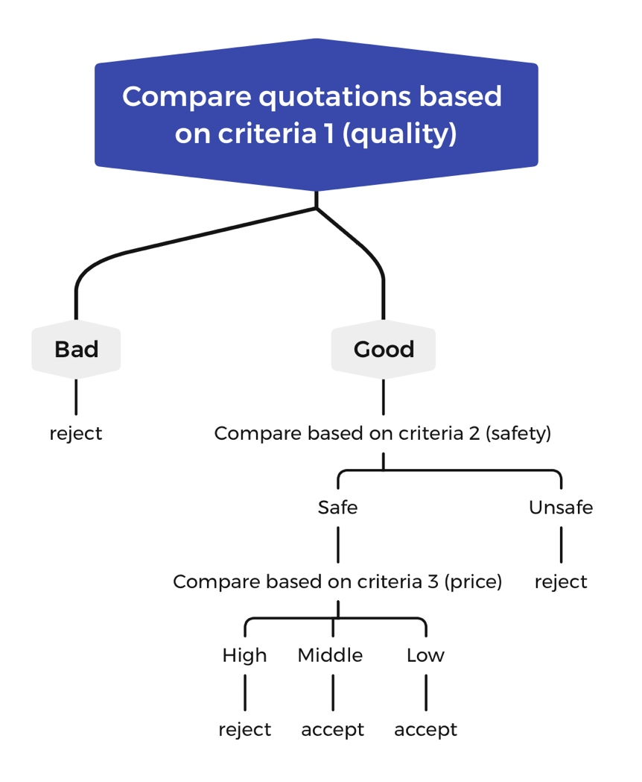

Figure 2: Criteria flow chart 1

In the first scenario, we prioritized quality over price when choosing materials. As can be seen in figure 2, any materials with quality below the company’s standard will be rejected regardless of how cheap it is. After finding materials that passes the quality inspection, we will then compare them in terms of durability and if it is safe for use. Finally, the materials approved in all previous criteria will be compared according to their prices. Naturally, in the interest of making profit, materials that are more expensive will be eliminated. Using criteria to classify the materials, we will be able to provide products with the best quality.

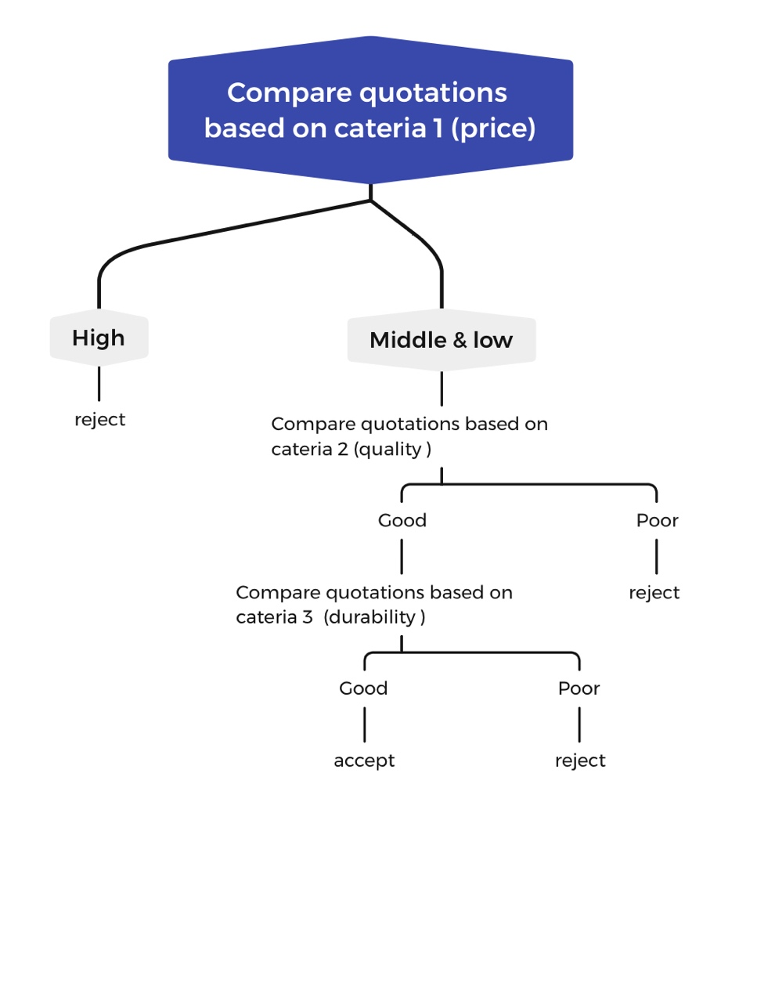

Figure 3: Criteria flow chart 2

However, frequently, the price will be the first deciding factor for most companies when selecting materials. Therefore, we designed this second scenario to prioritize the price while also maintaining the best possible quality. Firstly, after filtering the batch of materials based on a relatively low-price range, we then proceed to sort out more materials by evaluating them against several criteria as seen in Figure 3 which are quality and durability. Using these criteria to examine our materials, we will be able to identify which material is the best in terms of both price and quality. This is what we visualized how our material inspection process will look like in real life.

1. Thoughts of discount on the payment of ledger or keep up installments

Will there be any discount on expenses if we pay accounts payable in advance? After completing the challenge, we are curious to find out the answer to this question. This situation is likely to happen when companies want to increase the liquidity of cash flow. If discounts for early payments are allowed, in the transaction data, we speculate that the actual payment date and amount as well as the discounts conditions should be recorded in the SAP system during the MM process.

Furthermore, we also would like to investigate if can we pay the installments for this ledger. If possible, we think that the ‘Settle AP’ process may become a little more complicated, including recording the payment amount and payment date multiple times.

1. Thoughts on return goods

When the ordered goods are received in inventory, the material document and accounting document for goods movement will be created simultaneously. We will then receive the vendor invoice that will be used to check the accuracy of the prices and quantities of the materials we purchased. After checking that everything is as accordance to our expectance and our purchase, we will then proceed to payment. However, if the goods we received does not meet the company’s standards, we will be inclined to return the goods. Thus, we are interested to know how the MM process (system) will deal with this situation. In this case, we hypothesized that a debit note will need to be sent to vendor by the accounts department and then the supplier will send a credit note. Here, the supplier is the creditor, and the customer is the debtor. This is related to Material Requirement Planning (MRP), which will require us further studies before we can bring a conclusion to this problem.